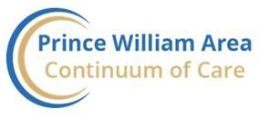

2021 Point in Time (PIT) Count MWCOG Jurisdictional Narrative

About Our Continuum

The Prince William Area Continuum of Care (PWA CoC) is comprised of nonprofit, faith-based, and government agencies throughout Prince William County and the cities of Manassas and Manassas Park. The PWA CoC provides operational policies and makes funding decisions for HUD and State funding. The PWA CoC meets monthly with a strong committee structure who reviews policies for consistency and best practices. Non-funded group members serve to make funding recommendations to the Governance Committee and then to the CoC. This group also reviews provider performance and holds them accountable for excellent service and strong internal controls.

Members of the CoC operate services to include prevention, diversion, street outreach, drop-in center, emergency shelter, transitional housing, rapid re-housing, permanent supportive housing, housing location and housing development. Providers collaborate to increase access to, and coordination of, services such as those related to housing, employment, benefits, education, health, and wellness.

A CoC member operates the Coordinated Entry System (CES) for the entire CoC with local funding. All people experiencing homelessness in need of services come through the CES. Certified Information and Referral staff operate this “front door” of the local homeless service system to assess barriers and connect persons experiencing a housing crisis to services. CES assists persons actively experiencing homelessness as well as those who may be at risk of homelessness. The CoC’s Service Continuum Committee updates the CES operational manual and makes recommendations for changes to the CoC.

Prince William County is 350 square miles, and the cities of Manassas and Manassas Park are independent jurisdictions located just west of mid-county. The population of people experiencing homelessness has grown in the west. In response, multiple western homeless advocates have come together to meet monthly and discuss how to serve. One such group, Serving Our Neighbors, became incorporated and developed a mobile Drop-In Center serving unsheltered adults one afternoon a week. This start is an impetus to grow a service continuum in the west that will be like the east, whose services have been in place for over twenty-five years.

PIT Count Outcomes

Overview

The PWA CoC conducted its annual count the night of January 27, 2021, as well as an additional “Service- Based Count” the following day. The “Service-Based Count” is a supplemental count that attempts to count anyone volunteers may have missed the night before. Volunteers visit places persons experiencing homelessness are known to congregate during the day such as public libraries, parks, and fast-food restaurants. Volunteers also survey persons seen panhandling to determine if they are actively experiencing homelessness.

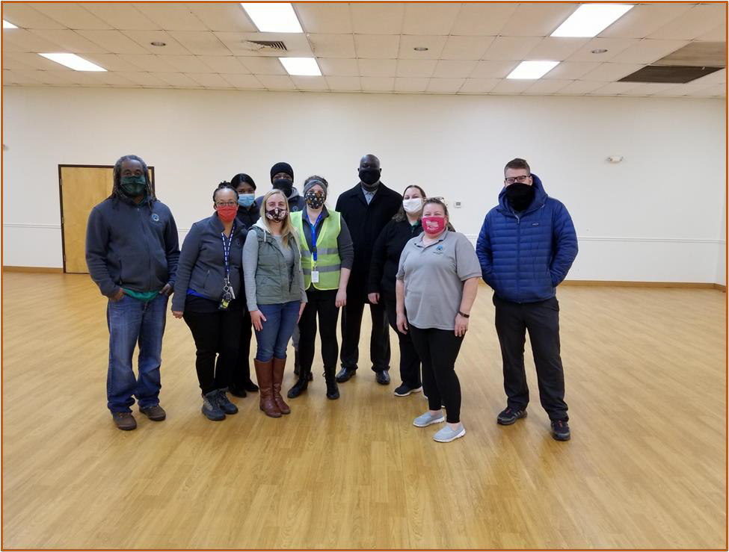
Members of PWC DSS leadership and the Homeless Services Team the night of the 2021 PIT

PIT Count methodology was largely unchanged from last year; however, additional safety measures and training were put in place due to the COVID-19 pandemic.

The following changes were made to our 2021 PIT Count Plan:
- The PIT Committee conducted direct outreach with entities that may have information on where unsheltered persons are sleeping.
- Recruitment of volunteers was focused on human service agencies, homeless services providers, and those with previous experience.
- A local government CoC member purchased PPE for all staff and volunteers as well as those being surveyed.
- Volunteer training included a review of COVID-19 safety measures such as proper mask usage and hand sanitation. Safety measures were reviewed by a medical professional with the George Mason University Mason and Partners Clinic.
- A “drive-thru” volunteer registration process at PIT headquarters which included a
health screening and temperature check was developed.
- Volunteers could conduct “observation surveys” in situations where approaching someone was not a feasible option.
- Gift cards were used as incentives.

Persons Served
The literally homeless count decreased by 14% from the 2020 count to the 2021 count. The decrease in persons served can be attributed to increased funding for “prevention” services as well as the standing eviction moratorium. Local providers received targeted funding to serve persons at risk of losing their housing without having to meet current homeless eligibility criteria. This is important because most current programs require persons to meet the definition of “literal homelessness” to receive services. This means that households at-risk of homelessness or that are precariously housed and/or “doubled-up” do not qualify for housing assistance.
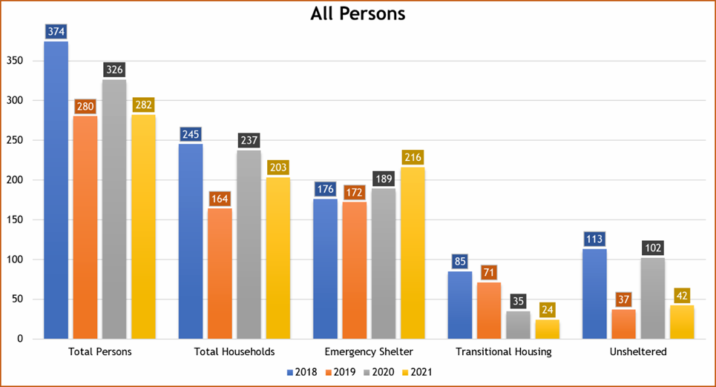
Counts of persons served decreased across the board except for Emergency Shelter - which saw a 14% increase. This growth is most likely due to improved services and increased capacity for hypothermia sheltering. In 2020, a CoC member provided 40 hypothermia beds but only served 19 persons in those beds the night of PIT. For 2021, the count of persons served increased by more than 237% with a total of 64 persons served. A CoC member provided local funding to provide hotel/motel shelter to persons sleeping outside during the winter months and coordinated access to services with local churches. Another CoC member provided funding for transportation services.

Unsheltered Homelessness
Increased hypothermia sheltering using hotels was a contributing factor to the decrease in the unsheltered count which is down by 59% from last year. Although this decrease is an indicator of success due to improved coordination and increased housing resources – it may also be an area of concern as the network enters the post-COVID period.
Challenges in obtaining information on “encampments” (i.e., places unsheltered persons are sleeping) were faced. Land development has left few areas for large camp sites making finding smaller camps harder. Another challenge is the lack of year-round data from current street outreach providers. There is only one formal street outreach program, and it just serves people with severe mental illness. Informal street outreach programs are active in the Homeless Advocates-West group. Using HMIS for informal groups will be an active effort in the coming year.
The effects of COVID-19 only compounded the above challenges as providers were forced to reduce street outreach activities due to the pandemic. Despite direct outreach and regular follow-ups with formal and informal providers, they were unable to share reliable data on encampments. The CoC largely relied on 2020 encampment data to map out their survey area. Many of the encampments volunteer teams visited the night of the count were visibly clean and well-kept but no one was physically there at the time. It is possible many of these persons were either in the hypothermia shelter or in other hotel/motel locations based on anecdotal information received from the community. The CoC has recognized the need for a more robust street outreach program and is actively working toward accomplishing that goal in FY2022.
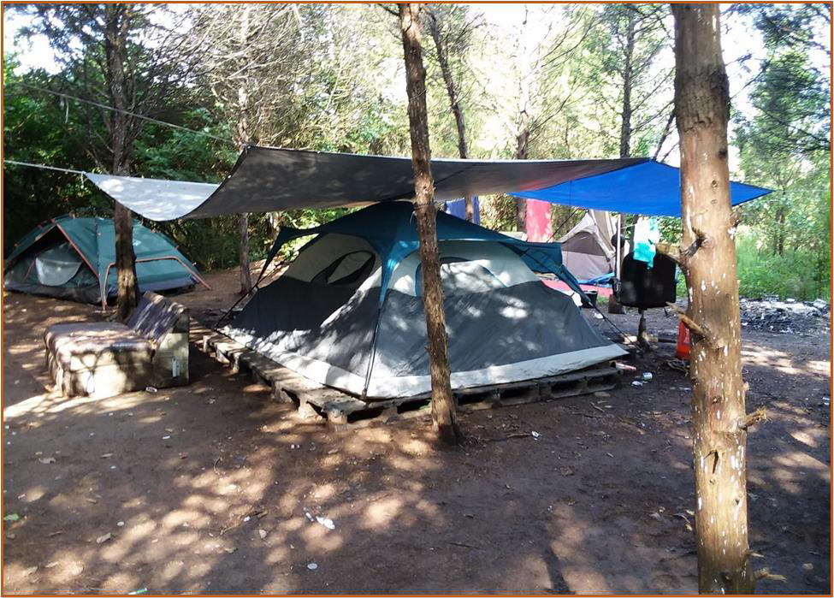
Photo of one of the encampments surveyed the night of the 2021 PIT

Households with Children
The number of persons in households with children decreased by 8% from the 2020 count to the 2021 count. However, the household count remains close to last year which indicates services are being provided to smaller families rather than fewer families. The CoC’s providers have been successful in reducing the number of families experiencing homelessness overall as seen in the chart below. There has been a 44% reduction in family homelessness since 2018. It is important to note part of this decrease is due to improved reporting and data quality.

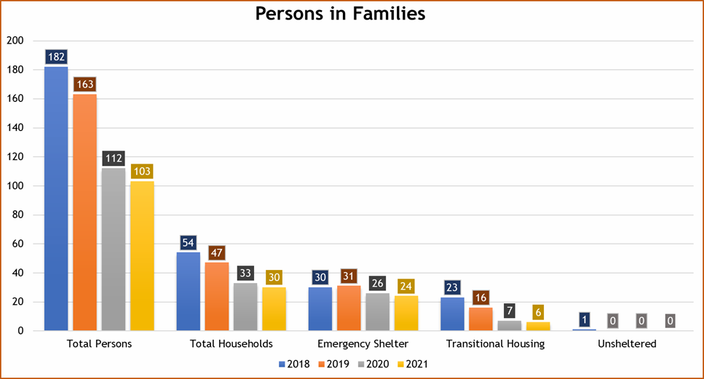

Adult-Only Households
The number of persons in adult-only households decreased by 16% from the 2020 count to the 2021 count which is largely due to the 59% decrease in the unsheltered count. We saw a 26% increase in persons in emergency shelter which is attributed to the improved winter plan for the hypothermia season. Adult- only households continue to be a vulnerable population in the PWA and represent 100% of the unsheltered population and 64% of the total population counted the night of PIT.
In October 2020, a CoC member began the process of transitioning a 48-bed overnight shelter to a full-time, year-round, shelter. This means adults experiencing homelessness will have more stability and access to services. Previously, case management services were limited and typically reserved for the most vulnerable residents. The shelter is fully staffed and has been in full operation since February.

Another success is the development of the new Emergency Supportive Shelter which offers eight beds for single adults with high barriers to housing. Persons reporting disabling conditions and other medical problems that inhibit their ability to live independently are at a high number. The new Emergency Supportive Shelter will provide needed stability for these persons and allow adequate time to overcome their barriers and obtain permanent housing.
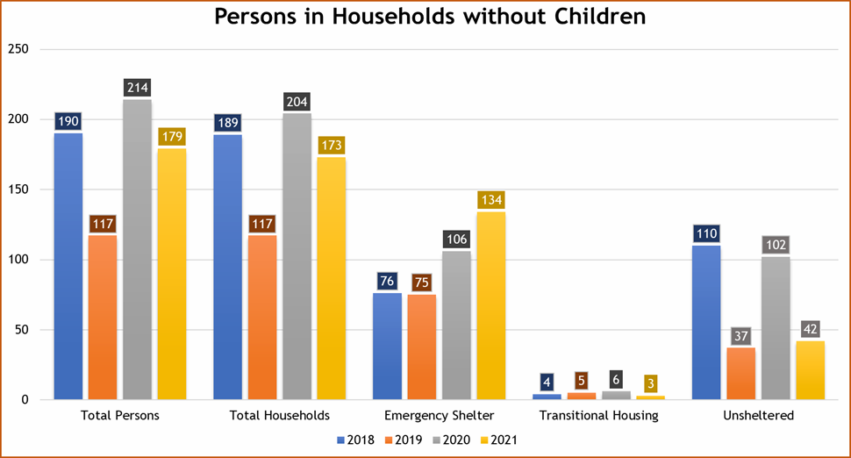

Race & Ethnicity of Persons Served
The PWA CoC strives to provide services in a manner that is equitable and free of discrimination and has conducted extensive work over the past three years to address systemic racial inequity. There has been a decrease in the number of persons identifying as Black/African American since 2019, however, they still represent more than 50% of the homeless population. This is especially concerning when compared to the most recent U.S. Census data from 2019 as persons identifying as Black/African American only represent 20% of the PWA’s general population.
The data on the ethnicity of persons served since 2019 has remained consistent with a slight increase (3%) in the number of persons identifying as Hispanic/Latino from the 2020 count. It should be noted there is a data quality concern when it comes to collecting data on race and ethnicity. This is due to how HUD defines race for persons identifying as Hispanic/Latino as their primary race is “white” unless they report otherwise. Often persons identifying as Hispanic/Latino will report they are “multi-racial” as they do not feel comfortable being reported as “white”. For 2020, data quality improved with better alignment with the HUD standards which could account for some of the decrease in the count for “multiple races” and the increase seen for persons reporting as “white”.

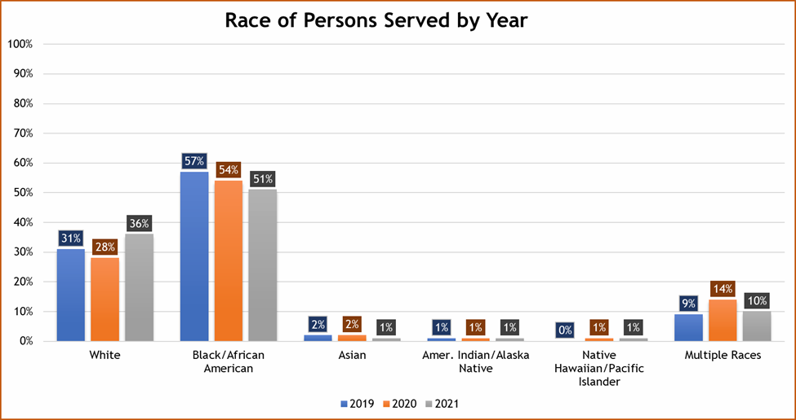
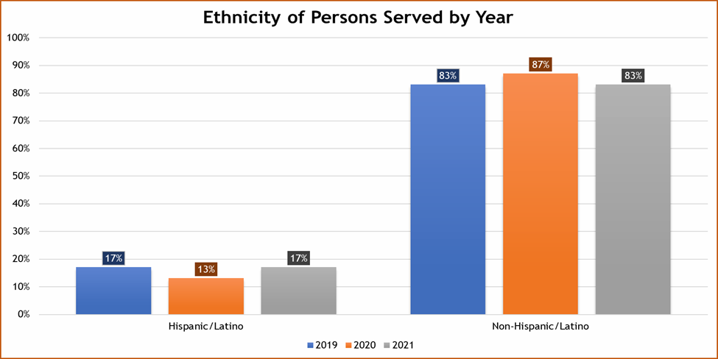

Income & Employment
Data on income and employment is provided for all adults (18+) counted in households the night of the PIT Count. There was not a significant change in the number of persons receiving income since last year; however, there has been a 23% decrease in the number of adults receiving income since 2019.
The number of adults who are employed decreased by 18% from the 2020 count to the 2021 count. There was a decrease in this number from the 2019 count to the 2020 count (23%). Gaining employment continues to be a challenge for many persons experiencing homelessness in the PWA CoC and the impact COVID-19 had on the economy further added to these challenges. Employment-based resources and partnerships with agencies providing these services has increased. A CoC provided started a new program that offers employment-focused case management to households enrolled in rapid re-housing. The program covers expenses related to job training and education to help persons expand their employable skills.
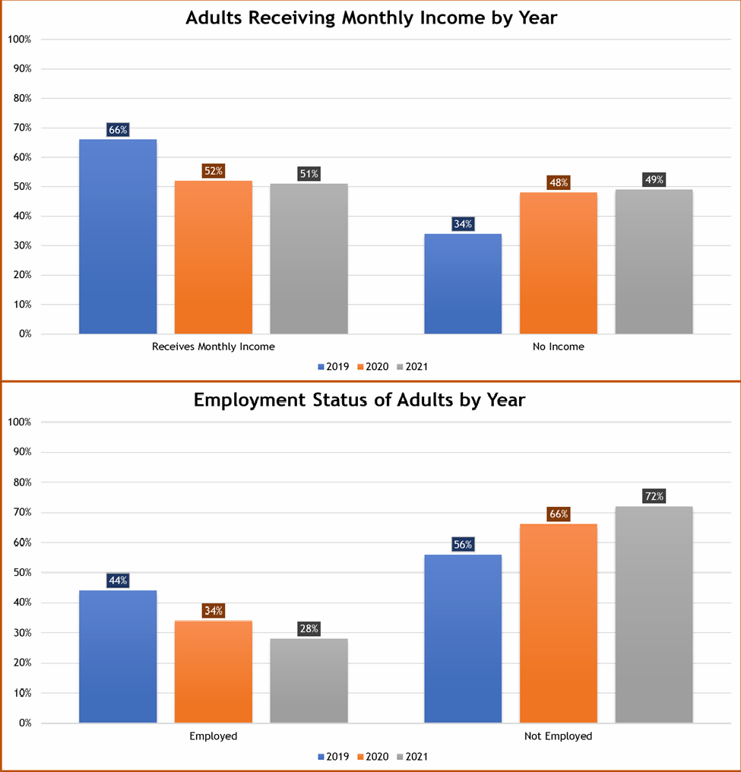

The table below shows the primary source of income by household rather than persons served. There has been a 16% decrease in the number of households whose primary source is employment income since 2020. There has been a 40% increase in the number of households whose primary source is some form of monthly disability income. Even though there was an increase of 6% in the number of households without income since 2020, it should be noted this is much lower than the increase of 31% from 2019 to 2020. This gives confidence that efforts to improve income retention for homeless households was effective.
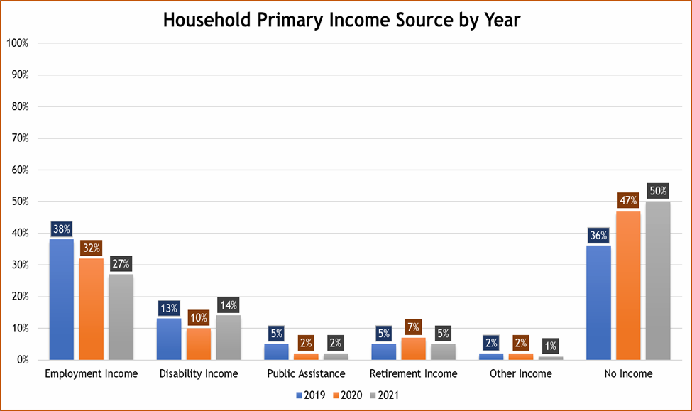

Priority Populations
The PWA CoC prioritizes households for services based upon their identified barriers as well as by “priority populations” such as households with children and persons who are chronically homeless. There is a significant need for permanent supportive housing based on the data for persons reporting as chronically homeless. Since 2019, two new PSH projects have begun and increasing this service is a continual effort.
There was a significant decrease in the number of persons reporting their current episode of homelessness being due to a release from an institution. The number of “formerly institutionalized” persons decreased by 29% from 2020 to 2021. Collaborating with area hospitals and the adult detention center has been successful by developing multidisciplinary teams for discharge planning protocols to reduce homelessness for persons at-risk of being released to homelessness. The data shows efforts to reduce veteran homelessness continue to be successful with a 67% reduction in persons counted since 2018.

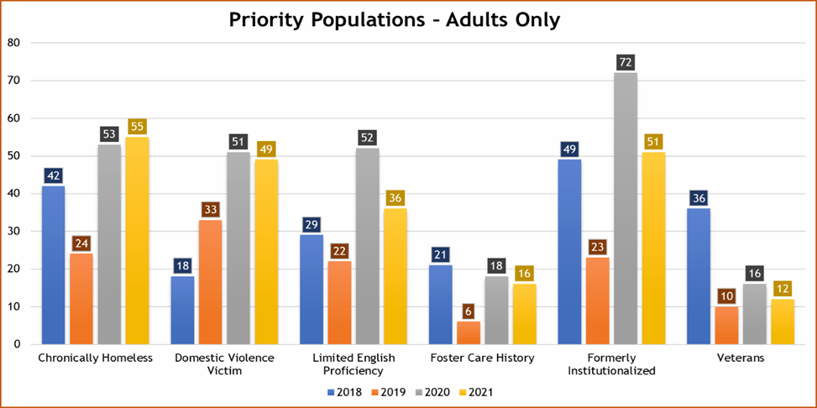

Disabling Conditions
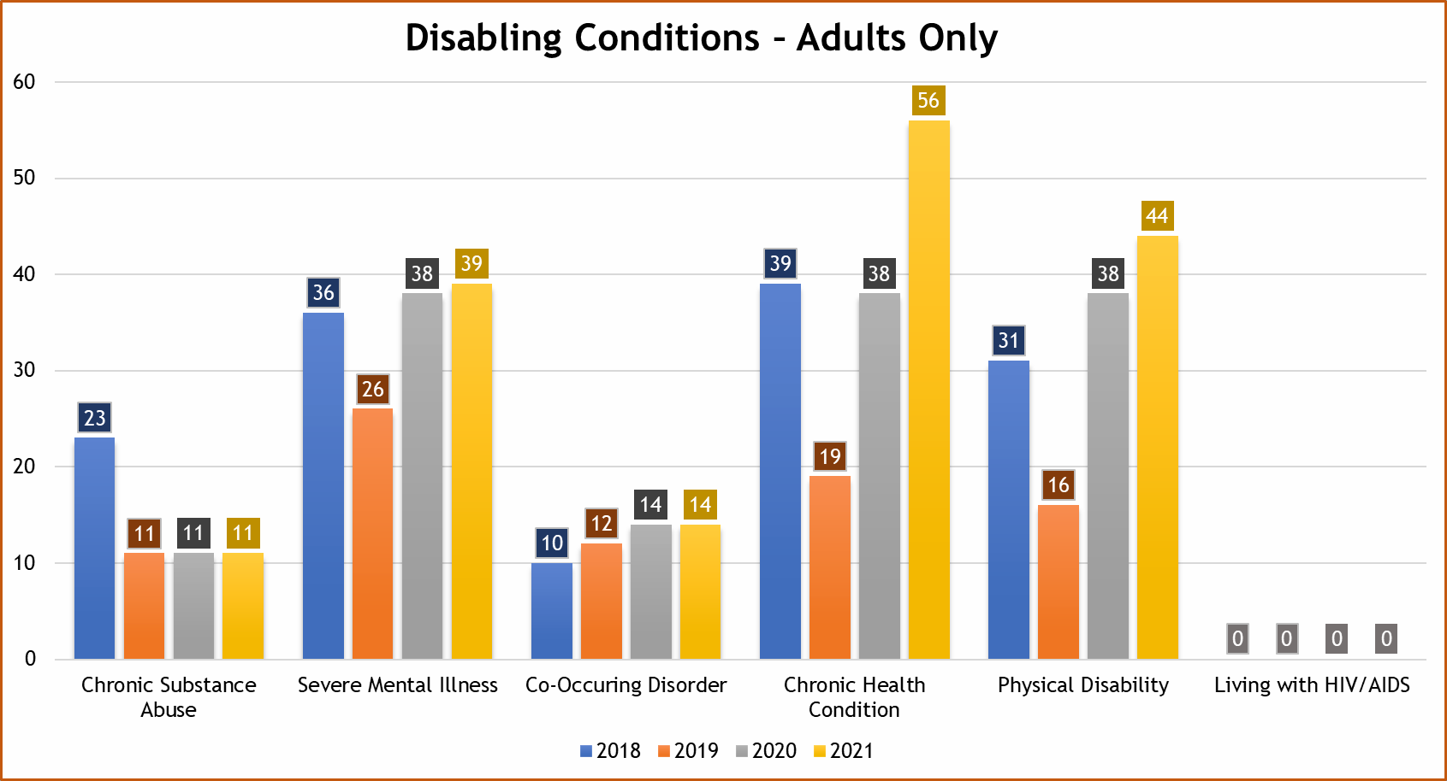
Many persons experiencing homelessness report living with a disabling condition that significantly impacts their day-to-day life. In 2021, 50% of adults surveyed reported living with one or more disabling conditions. The data for substance abuse, mental illness, and co-occurring disorders remains consistent, however, there was a 47% increase in reported chronic health conditions and a 16% increase in reported physical disabilities. This increase could explain the 40% increase seen in households whose primary income source is some form of disability income.

Shelter Inventory
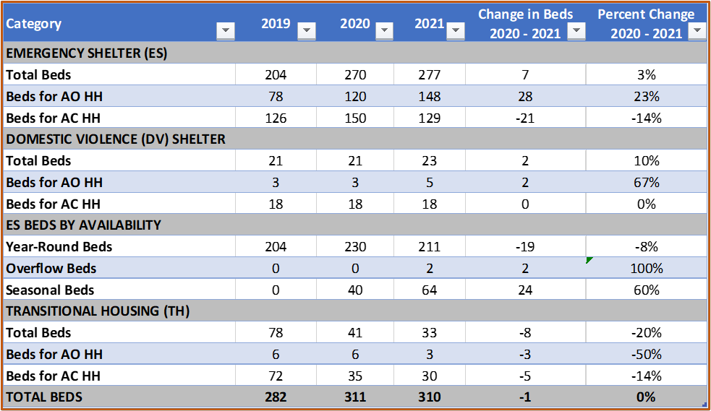
The PWA had a total of 310 sheltered beds (emergency shelter and transitional housing) available the night of the 2021 PIT. This results in a utilization rate of 77% based on the 240 persons served in sheltered projects. The COVID-19 pandemic has affected utilization in shelter projects due to social distancing requirements. Additionally, providers have had to utilize family rooms to quarantine single persons who have been exposed to and/or diagnosed with COVID.

Permanent Housing Outcomes

Permanent Housing
Members of the PWA CoC currently operate six Permanent Supportive Housing (PSH) projects and 13 Rapid Rehousing (RRH) projects. There was a 13% increase in PSH beds and a 17% increase in RRH beds since 2020. One positive to come out of the pandemic has been the increased funding received for RRH services. The CoC has begun three new RRH projects, which all receive HUD ESG CV (CARES) funding. A new PSH project started on 10/1/2020 which brought 11 new beds for single individuals to the PWA. The CoC served 46 persons in PSH the night of the 2021 PIT which is a 12% increase from 2021. All PSH beds remain dedicated to chronically homeless persons and their families.
RRH providers continue to successfully move households into their new homes quickly and effectively. Since the beginning of the fiscal year (7/1/2020), 88% of persons enrolled in RRH moved into a permanent housing unit. Of those persons, 81% moved from homelessness into housing in less than thirty (30) days. Further success in RRH projects saw the point of exit as 73% of those exiting “transitioned in place” meaning they no longer require services and have assumed full responsibility of their rental unit.
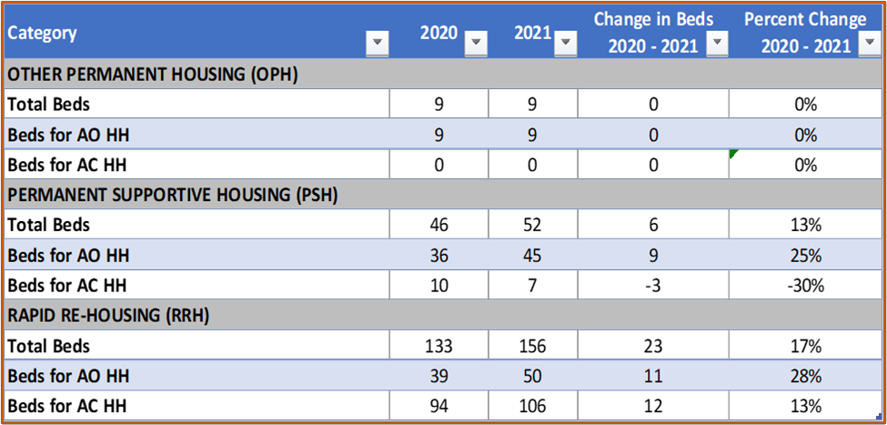

Positive Exit Destinations

Since the beginning of the fiscal year (7/1/2020) through the night of the 2021 PIT, 76 persons exited to permanent housing destinations other than PSH and RRH. This information is determined using HMIS data for emergency shelter, transitional housing, and street outreach projects. This is important as it supports efforts to provide diversion services beyond coordinated entry and therefore reserve limited housing resources for households with higher barriers.

Other Permanent Housing
CoC members also operate two “other” permanent housing projects that are privately funded but still utilize the HMIS and participate in reporting. These projects offer permanent housing to single individuals with or without a disability as well as supportive services. Both projects remain at 100% capacity, as in 2020, serving a total of 9 individuals.

