Tips for Managing and Reducing Yard Waste

Grasscycling and composting may not come to mind when you think about waste reduction and recycling, but they are both great examples of these concepts. Yard waste is one of the largest categories of waste. It makes up more than 13% of the total trash generated nationally as well as in Prince William County.

Grasscycling
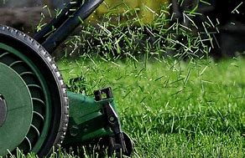
Grasscycling is an easy and natural approach to maintaining a lawn and it is a great waste reduction practice. Just remove the bag and almost any lawnmower can grasscycle* Grass clippings are simply left on the lawn after mowing. The grass clippings will decompose quickly and release valuable nutrients back into the soil.

Grasscycling has many benefits: it saves time, money and the resources needed to pick up and prepare the clippings for landfilling; and grass clippings decompose quickly and release valuable nutrients back into the soil. Overall, grasscycling can reduce water and fertilizer requirements, mowing time, and save money. Plus, it benefits the environment by reducing waste, saves valuable landfill space and reduces fertilizer usage and the harmful runoff it produces.

*Caution: If the mower does not have a safety flap that covers the bag chute opening, or a plug for the chute, purchase a retrofit kit. Do not compromise the mower's safety systems.

Composting
Composting is nature’s recycling, and it is a great technique to use for managing waste from the lawn and garden. Composting is a natural process, which speeds up the natural decomposition of organic matter (e.g., grass, leaves, garden debris, food waste, etc.). Composting “recycles” organic matter into a valuable soil amendment called compost.

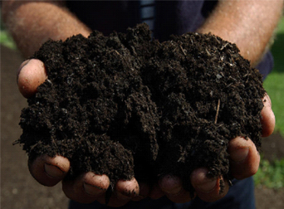
Instead of bagging up leaves, grass clippings and other garden waste—try composting them instead. Raked leaves, mowed grass and trimmed bushes and branches can all be used to make valuable landscape and garden loving compost. No special equipment is needed, but a compost bin will help keep the compost area tidy. Compost bins are available at local hardware stores, on-line and at the Balls Ford Road Compost Facility.

Finished compost can be used to improve the soil structure, which helps keep the soil together and reduces erosion. Compost can be used in vegetable gardens and flower beds, lawns, and even mixed with potting soil.

Tip: If leaves must be collected for disposal, mow the leaves before you rake them, or collect the mowed leaves in your mower’s bag. This simple step reduces the number of bags, or containers needed for collection.

To learn more about yard waste composting, grasscycling, mowing height, watering, lawn management, etc., visit internet sites like Virginia Cooperative Extension, www.ext.vt.edu; Prince William Library pwcgov.org/digitallibrary or other information resources or email Extension Horticulture Help Desk weekdays at master_gardener@pwcgov.org.

To learn more about guidelines for disposal at the Prince William County Landfill and the Balls Ford Compost facility, please visit www.pwcva.gov/trashandrecycling.

