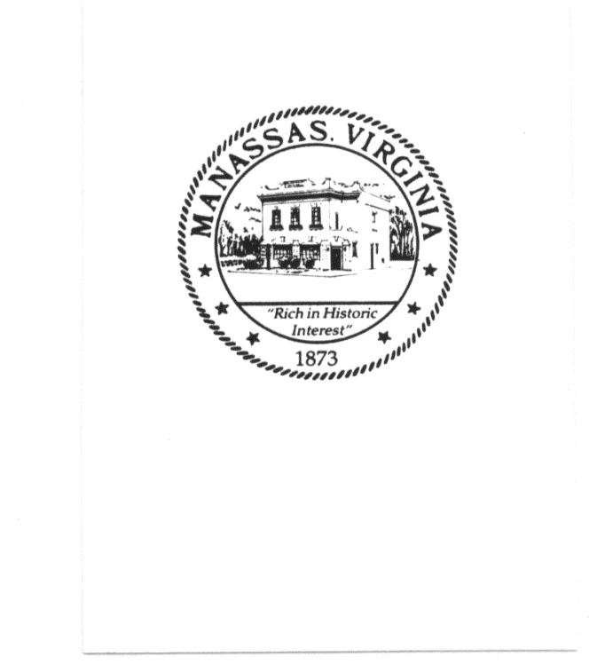

## **PRINCE WILLIAM-MANASSAS**

## **Regional Adult Detention Center**

## **9320 Lee Avenue**

## **Manassas, Virginia 20110**

**703-792-6420**

**703-792-6718 Fax**

**703-792-6718 Fax**



**PRINCE WILLIAM – MANASSAS REGIONAL JAIL BOARD**

**AGENDA**

**Regular Meeting – September 15, 2021**

**Central Building**

**9320 Lee Avenue**

**Manassas, VA 20110**

1. Meeting Call to Order and Roll Call 6:00 P.M.

2. Public Comments – Public written comments are being received until 6:05 P.M.

5:00 p.m. on Monday, September 13, 2021. They will be made

available to the Jail Board and to the Public on Tuesday,

September 14, 2021.

Five (5) members of the public can address the Board in-person.

3. Approval of Agenda – September 15, 2021 6:15 P.M.

4. Approval of Minutes 6:20 P.M.

a) Regular Meeting – July 21, 2021

5. Superintendent’s Report 6:25 P.M.

a) Inmate Population Report

b) Status of FY 2022 Objectives

c) Other Comments

6. Budget Update 6:50 P.M.

7. Jail Board Members Comments 7:15 P.M.

8. Adjournment 7:30 P.M.

**Pending Issues**

1. Report of Jail Population Statistics

(presented 03/17/2021, 07/21/2021, 11/17/2021)

1. Election of Jail Board Officers and Appointment of Jail Board Secretary

(conducted during the May Jail Board meeting)