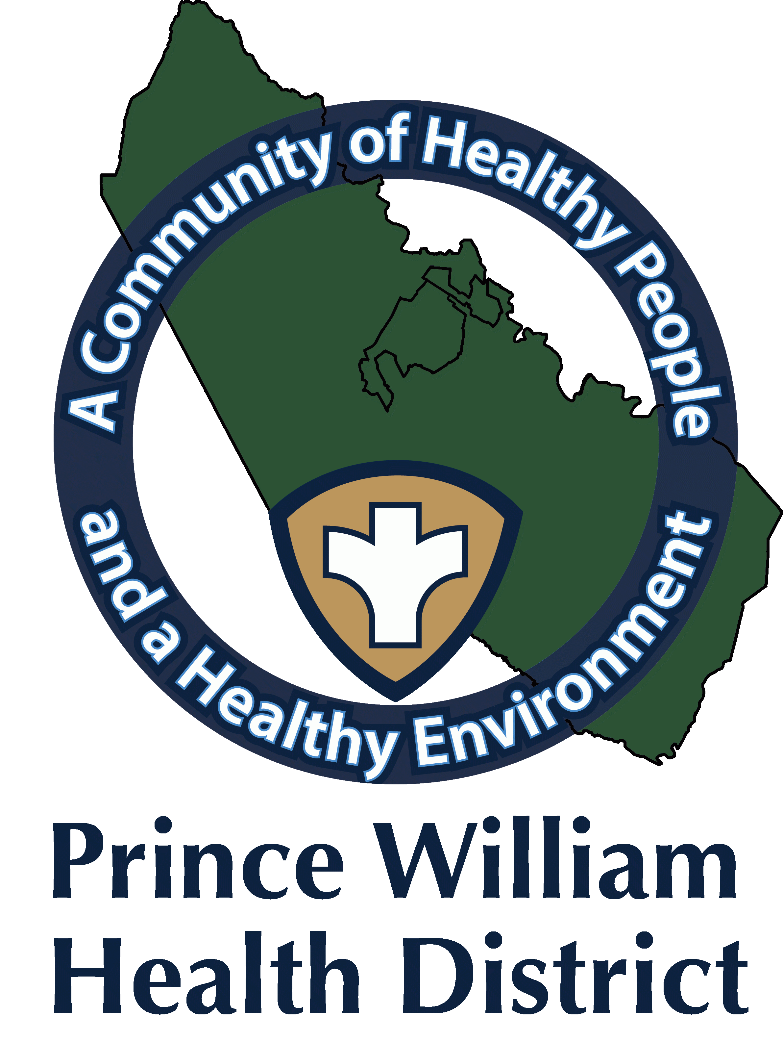

Information Update

Community Outreach Director
Sean Johnson
Sean.johnson@vdh.virginia.gov
August 27, 2021

The Prince William Health District What You Should Know:

The Food and Drug Administration (FDA)
Approves First COVID-19 Vaccine

On August 23, The Food and Drug Administration (FDA) approved the first COVID-19 vaccine. The vaccine known as the Pfizer-BioNTech COVID-19 Vaccine, will now be referred medically as Cominarty (Koe-mir’-na-tee), for the prevention of COVID-19 disease in individuals 16 years of age and older. Although the vaccine has met FDA approval for 16 and older, the vaccine continues to be available for individuals 12 through 15 years old under an emergency use authorization (EUA), and for administering of a third dose in certain immunocompromised individuals.

The FDA’s approval of this vaccine means it has met the FDA’s rigorous, scientific standards. The public can rest assure that this vaccine meets the high standards for safety, effectiveness, and manufacturing quality the FDA requires of an approved product. We hope this approval builds confidence that a COVID-19 vaccine is another means in fighting the pandemic and keeping you and your loved ones safe.

Mobile Clinic Unit Special Events

- Saturday, August 28, from 9:00 a.m.-1:00 p.m.
- Iglesia Ebenezer Community Health & Resources Fair
- 13646 Jefferson Davis Hwy., Woodbridge
- First, Second, and Third doses. People who are immunocompromised may receive a third dose.
- COVID-19 Vaccines Pfizer (for 12 and older) Johnson and Johnson (18 and older). No appointments are required. Walk-ins are accepted as long as supplies lasts. Weather permitting.

- Saturday, August 28, from 4 p.m.-6 p.m.
- Mr. Ray’s Barbershop 13895 Hedgewood Dr. Suite 317, Woodbridge
- Mr. Ray’s Barbershop in partnership with Performance Plus International (PPIINC), are offering for the first 25 individuals vaccinated a free haircut.
- You must call ahead 571-758-9292 and request COVID Cut.
- First, Second, and Third doses. People who are immunocompromised may receive a third dose.
- COVID-19 Vaccines Pfizer (for 12 and older) Johnson and Johnson (18 and older).
- No appointments are required. Unless requesting a free haircut, and Walk-ins are accepted as long as supplies lasts without a free cut. Weather permitting.

Vaccine Clinic Manassas Mall

- Monday, August 30, from 4 p.m.-8 p.m.
- Manassas Mall 8300 Sudley Rd., Manassas
- First, Second, and Third doses. People who are immunocompromised may receive a third dose.
- COVID-19 Vaccines Pfizer (for 12 and older).
- No appointments are required. Walk-ins are accepted as long as supplies lasts.

Mobile Clinic Unit

- Tuesday, August 31, from 1 p.m.-4 p.m.
- Todos Supermarket, 13905 Jefferson Davis Hwy., Woodbridge
- First, Second, and Third doses. People who are immunocompromised may receive a third dose.
- COVID-19 Vaccines Pfizer (for 12 and older) Johnson and Johnson (18 and older).
- No appointments are required. Walk-ins are accepted as long as supplies lasts. Weather permitting

- Tuesday, August 31, from 5 p.m.-8 p.m.
- Americana Grocery, 14428 Jefferson Davis Hwy., Woodbridge
- First, Second, and Third doses. People who are immunocompromised may receive a third dose.
- COVID-19 Vaccines Pfizer (for 12 and older) Johnson and Johnson (18 and older).
- No appointments are required. Walk-ins are accepted as long as supplies lasts. Weather permitting

