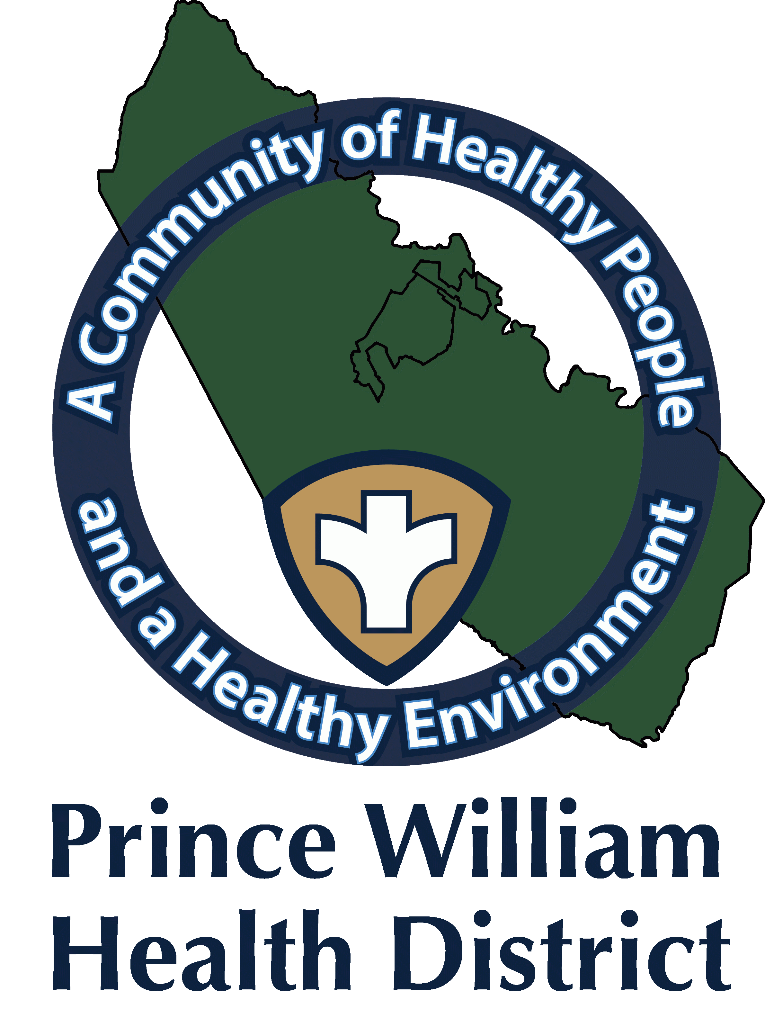

Information Update
Community Outreach Director
Sean Johnson
Sean.johnson@vdh.virginia.gov
September 27, 2021

The Prince William Health District What You Should Know:

Those eligible for the [Pfizer-BioNTech] booster dose include:

- people 65 years and older and residents in long-term care settings should receive a booster shot of Pfizer-BioNTech’s COVID-19 vaccine at least 6 months after their Pfizer-BioNTech primary series.

- people aged 50–64 years with underlying medical conditions should receive a booster shot of Pfizer-BioNTech’s COVID-19 vaccine at least 6 months after their Pfizer-BioNTech primary series.

- people aged 18–49 years with underlying medical conditions may receive a booster shot of Pfizer-BioNTech’s COVID-19 vaccine at least 6 months after their Pfizer-BioNTech primary series, based on their individual benefits and risks. Talk with your health care provider.

- people aged 18-64 years who are at increased risk for COVID-19 exposure and transmission because of occupational or institutional setting may receive a booster shot of Pfizer-BioNTech’s COVID-19 vaccine at least 6 months after their Pfizer-BioNTech primary series, based on their individual benefits and risks. Talk with your health care provider.

Occupations at increased risk for COVID-19 exposure and transmission include front line essential workers and health care workers as previously detailed by the CDC*

- First responders (healthcare workers, firefighters, police, congregate care staff)
- Education staff (teachers, support staff, daycare workers)
- Food and agriculture workers
- Manufacturing workers
- Corrections workers
- U.S. Postal Service workers
- Public transit workers
- Grocery store workers
*List could be updated in the future

Prince William Health District encourages all eligible persons to get their COVID-19 vaccine if they haven’t already done so. To find a vaccination site near you, visit vase.vdh.virginia.gov or visit www.vaccines.gov.

If you are coming for your booster dose, please bring your vaccine card to confirm the date and type of vaccine you received in your second dose.

Vaccine Clinic

- Monday September 27, from 12:00 p.m. -4:00 p.m.
- Manassas Mall, 8300 Sudley Rd., Manassas, VA. 20109
- First, Second, and Third doses for those eligible for the Pfizer-BioNTech Booster dose.
- COVID-19 Vaccines Pfizer (for 12 and older), and Moderna (18 and older).
- No appointments are required. Walk-ins are accepted as long as supplies last.

Mobile Clinic Unit

- Tuesday September 28, from 3:30 p.m.- 6:30 p.m.
- La Azteca Grocery, 2928 Dale Blvd., Woodbridge, VA. 22193
- First, Second, and Third doses for those eligible for the Pfizer-BioNTech Booster dose.
- COVID-19 Vaccines Pfizer (for 12 and older) Johnson and Johnson (18 and older).
- No appointments are required. Walk-ins are accepted as long as supplies last. Weather permitting

- Thursday September 30, from 12:00 p.m.- 2:30 p.m.
- 7-Eleven, 9166 Mathis Ave., Manassas, VA. 20110
- First, Second, and Third doses for those eligible for the Pfizer-BioNTech Booster dose.
- COVID-19 Vaccines Pfizer (for 12 and older) Johnson and Johnson (18 and older).
- No appointments are required. Walk-ins are accepted as long as supplies last. Weather permitting.

- Thursday, September 30, from 4:00 p.m.- 6:30 p.m.
- Manassas Mobile Home Park, 9011 Centreville Rd., Manassas VA. 20110
- First, Second, and Third doses for those eligible for the Pfizer-BioNTech Booster dose.
- COVID-19 Vaccines Pfizer (for 12 and older) Johnson and Johnson (18 and older).
- No appointments are required. Walk-ins are accepted as long as supplies last. Weather permitting

Testing: If you think you may have COVID-19, you can visit the VDH website to locate COVID-19 testing sites or visit
https://www.hhs.gov/coronavirus/community-based-testing-sites/index.html
Also, you can reach out to your healthcare provider for COVID-19 testing. Pharmacies offer COVID-19 testing and sell over-the-counter home testing kits.
https://www.vdh.virginia.gov/coronavirus/covid-19-testing/walgreens-partnership/

