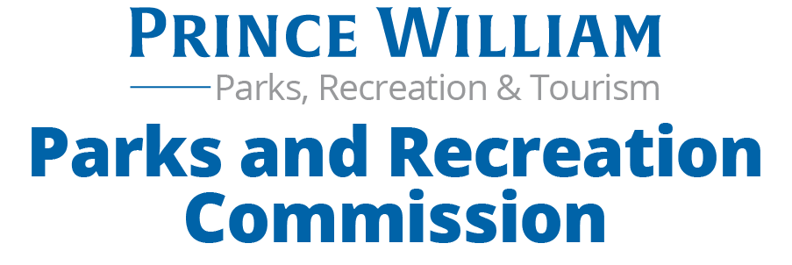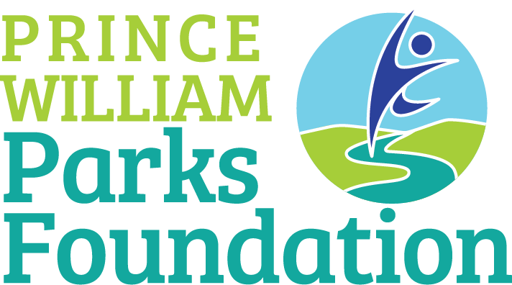

NOTICE OF PUBLIC MEETING
September 25, 2021, 9:45 am
The Prince William County Parks and Recreation Commission and Prince William Parks Foundation will be participating in a joint bus tour of the park sites listed below.
The purpose of this meeting is to visit and become familiar with sites that are representative of each type of Park in our system and discuss how they all fit in our Parks, Recreation and Tourism Master Plan. Due to the nature of the tour and traffic considerations it is not possible to provide an exact time that the tour will arrive at each location.
Saturday Sept 25
- meet at Hellwig Park Administrative Bldg. (14420 Bristow Rd. Manassas 20112) at 9:45 am
- depart Hellwig at 10:00 am, passing Shenandoah Park enroute to
- Doves Landing/ Sinclair Mill property, passing Brentsville Court House and Bristow Battlefield enroute to
- Ellis Barron Park, passing Anne Moncure Wall Park enroute to
- Locust Shade Park, passing Generals Ridge Golf Course enroute to
- Hellwig Park - Tour ends approximately 2 pm
For additional information about this tour please contact the Secretary to the Commission at sjaenicke@pwcgov.org

