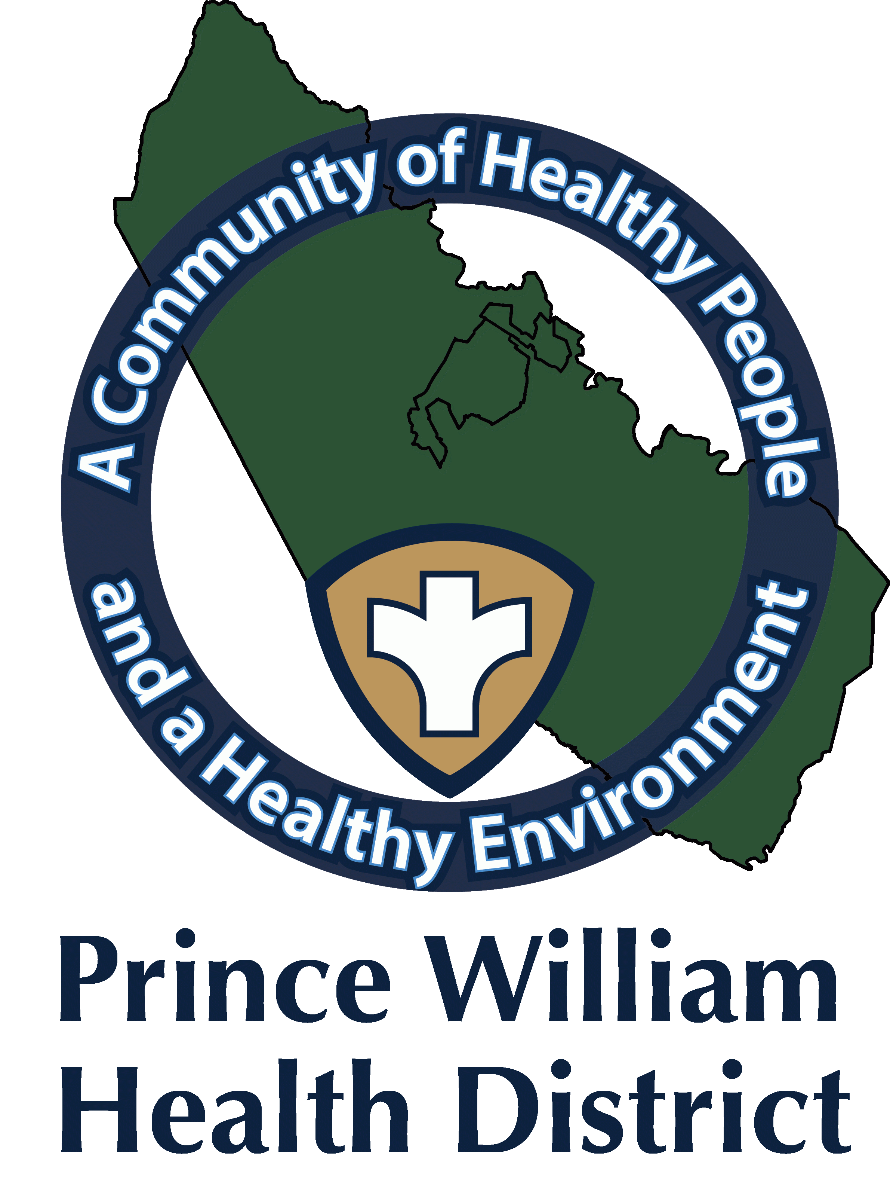

Information Update
Community Outreach Director
Sean Johnson
Sean.johnson@vdh.virginia.gov
October 22, 2021

The Prince William Health District What You Should Know:

CDC Expands Eligibility for COVID-19 Booster Shots

- CDC director endorsed the CDC Advisory Committee on Immunization Practices’ (ACIP) recommendation for a booster shot of COVID-19 vaccines in certain populations.
- For individuals who received a Pfizer-BioNTech or Moderna COVID-19 vaccine, the following groups are eligible for a booster shot at 6 months or more after their initial series:
    - 65 years and older
    - Age 18+ who live in long-term care settings
    - Age 18+ who have underlying medical conditions
    - Age 18+ who work or live in high-risk settings

- For people who got the Johnson & Johnson COVID-19 vaccine, booster shots are also recommended for those who are 18 and older and who were vaccinated two or more months ago.
- CDC’s recommendations now allow for heterologous (or “mix and match”) booster doses. Eligible individuals may choose which vaccine they receive as a booster dose. Some people may prefer the vaccine type that they originally received, and others may prefer to get a different booster.
Significant changes to the CDC guidance

Community Vaccination Clinic

community Vaccination Center, Located at the former Gander Mountain store, 14011 Worth Avenue, Woodbridge, VA 22192. offering first, second, third, and booster doses for the Pfizer BioNtech, Moderna, and Johnson & Johnson vaccines. Vaccines are free.
The CVC will have appointments Mondays through Saturdays from 10 a.m. to 7:30 p.m., Walk-ins accepted.
To get a vaccine it is recommended that you make an appointment, visit vaccinate.virginia.gov or call 877-VAX-IN-VA (877-829-4682, TTY users call 7-1-1). Assistance is available in English, Spanish, and more than 100 other languages.

Bring your COVID-19 vaccine card or vaccine record with QR code. If you need a copy of your vaccine record, visit vaccinate.virginia.gov Masks must be worn at the
CVC.

Manassas Mall Clinic

Manassas Mall vaccination site six days per week offering first, second, third, and booster doses for the Pfizer BioNtech, Moderna, Johnson & Johnson vaccines. These doses will be offered on various days. The Mall is located at, 8300 Sudley Rd, Manassas, VA 20109. Vaccines are free.
To get a vaccine it is recommended that you make an appointment, visit vaccinate.virginia.gov or call 877-VAX-IN-VA (877-829-4682, TTY users call 7-1-1). Assistance is available in English, Spanish, and more than 100 other languages. However, walk-ins are accepted at certain days/times (see below).

Mall Clinic Hours:

- Mondays: 12 p.m. to 4 p.m. (walk-ins accepted, vaccines offered: Pfizer, and Moderna). The Flu vaccine will be offered while supplies last.

- Tuesdays: 11 a.m. to 6 p.m. (clinic closed 2:30 p.m. to 3:00 p.m., walk-ins accepted from 1:00 p.m. to 2:30 p.m., vaccines offered: Pfizer, Moderna, Johnson & Johnson)

- Wednesdays: 11 a.m. to 6 p.m. (clinic closed 2:30 p.m. to 3:00 p.m., walk-ins accepted from 1:00 p.m. to 2:30 p.m., vaccines offered: Pfizer, Moderna, Johnson & Johnson)

- Thursdays: 11 a.m. to 6 p.m. (clinic closed 2:30 p.m. to 3:00 p.m., walk-ins accepted from 1:00 p.m. to 2:30 p.m., vaccines offered: Pfizer, Moderna, Johnson & Johnson)

- Fridays: 12 p.m. to 4 p.m. (walk-ins accepted, vaccines offered: Pfizer, and Moderna). The Flu vaccine will be offered while supplies last.

- Saturdays: 9 a.m. to 5 p.m. (clinic closed 12:30 p.m.-1:00 p.m., walk-ins accepted from 1:00 p.m. to 2:30 p.m., vaccines offered: Pfizer, Moderna, Johnson & Johnson)
.
Mobile Clinic Unit

- Wednesday October 27, from 2:00 p.m.-6:00 p.m.
- Prince William Chamber of Commerce (Salute to Armed Forces)
- 2500 Neabsco Common Place, Woodbridge, Va. 22191.
- First, second, third doses, and for those eligible for the Pfizer-BioNTech, Moderna, and Johnson & Johnson Booster dose.
- COVID-19 Vaccines Pfizer (for 12 and older) Johnson and Johnson (18 and older).
- The Flu vaccine will be offered while supplies last.
- No appointments are required. Walk-ins are accepted as long as supplies lasts. Weather permitting.

- Thursday October 28, from 12:00 p.m. -2:30 p.m.
- Guapos, 8498 Centreville Rd., Manassas Park, Va. 20111
- First, second, third doses, and for those eligible for the Pfizer-BioNTech, Moderna, and Johnson & Johnson Booster dose.
- COVID-19 Vaccines Pfizer (for 12 and older) Johnson and Johnson (18 and older).
- The Flu vaccine will be offered while supplies last.
- No appointments are required. Walk-ins are accepted as long as supplies lasts. Weather permitting.

- Thursday October 28, from 4:00 p.m. -6:30 p.m.
- Fresh World grocery, 9540 Liberia Ave., Manassas Va. 20110
- First, second, third doses, and for those eligible for the Pfizer-BioNTech, Moderna, and Johnson & Johnson Booster dose.
- COVID-19 Vaccines Pfizer (for 12 and older) Johnson and Johnson (18 and older).
- The Flu vaccine will be offered while supplies last.
- No appointments are required. Walk-ins are accepted as long as supplies lasts. Weather permitting.

- Testing: If you think you may have COVID-19, you can visit the VDH website to locate COVID-19 testing sites or visit
- https://www.hhs.gov/coronavirus/community-based-testing-sites/index.html
- Also, you can reach out to your healthcare provider for COVID-19 testing. Pharmacies offer COVID-19 testing and sell over-the-counter home testing kits.
- https://www.vdh.virginia.gov/coronavirus/covid-19-testing/walgreens-partnership/

