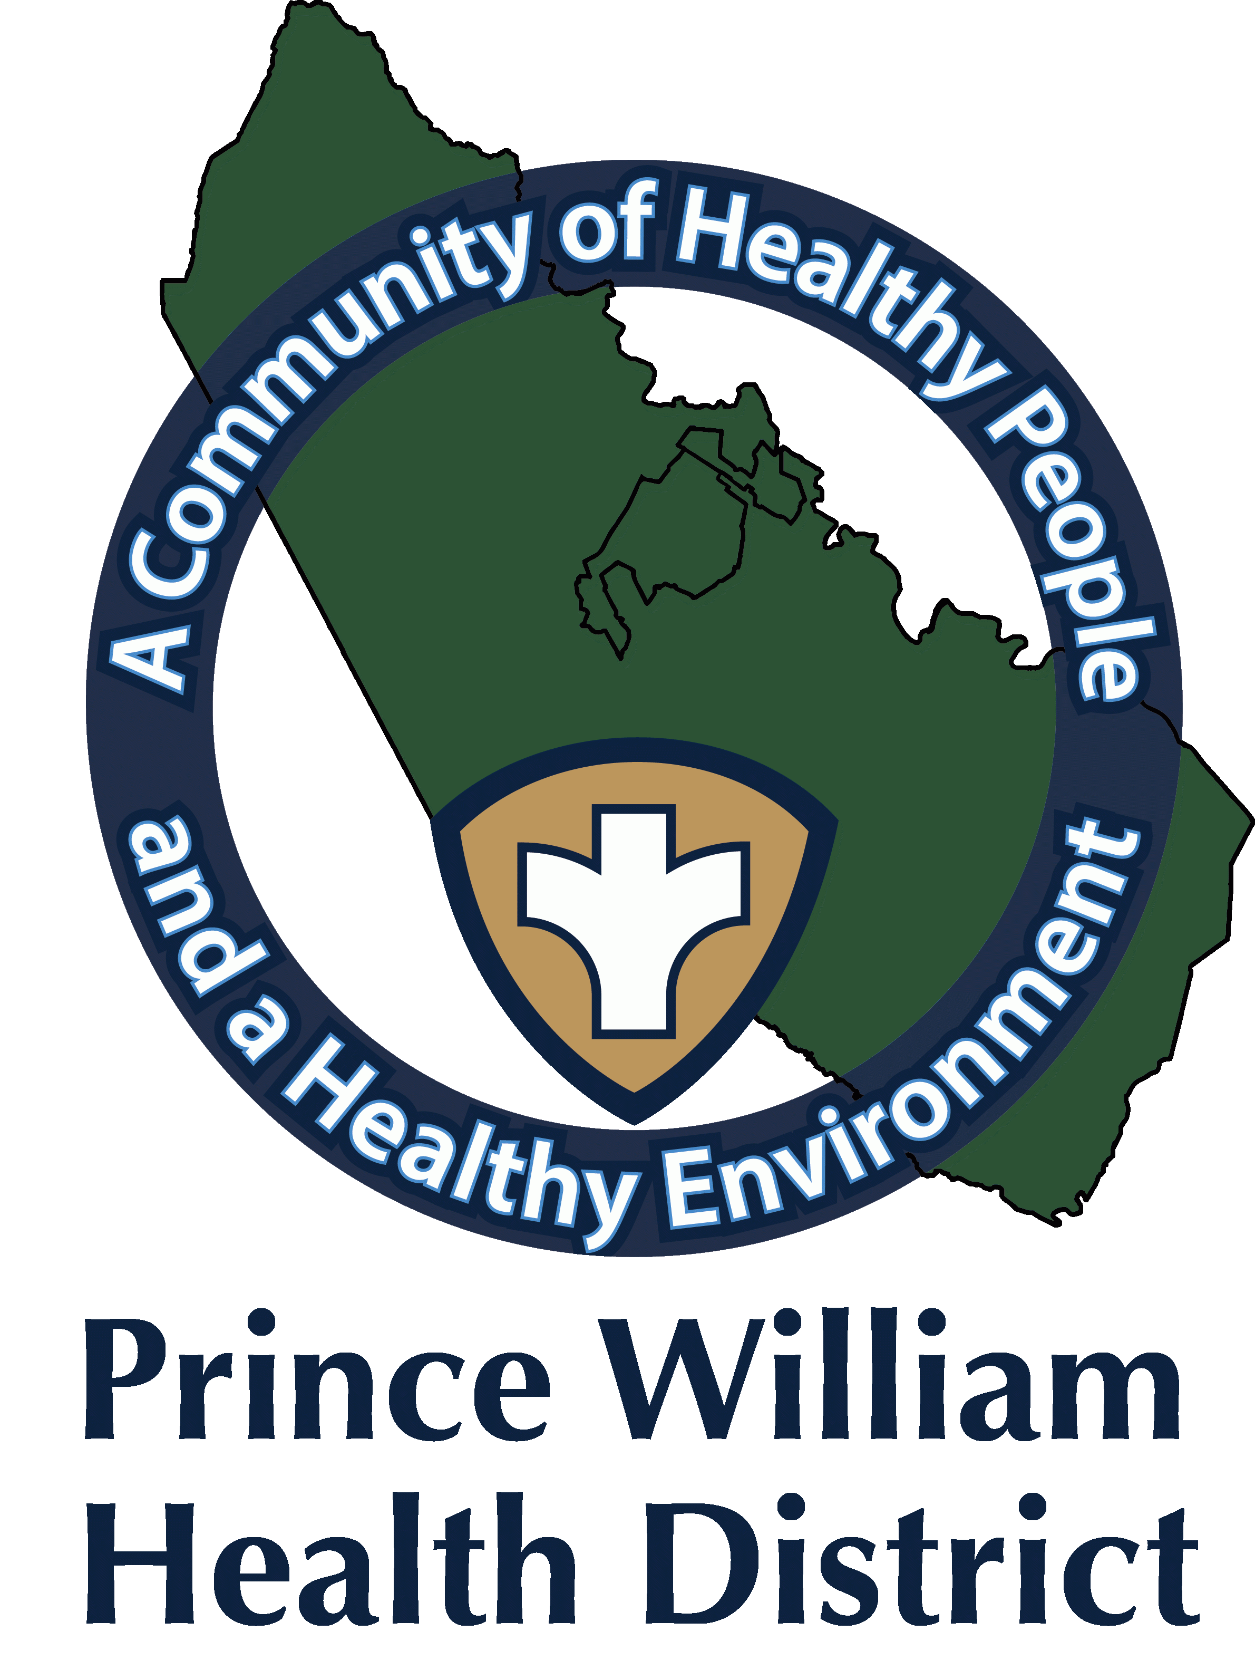

Information Update
Public Information Officer
Kathy Stewart
Kathy.stewart@vdh.virginia.gov
November 4, 2021

The Prince William Health District Begins Offering Pfizer-BioNTech COVID-19 Vaccine for Children Ages 5-11

Today, November 4, 2021, the Pfizer-BioNTech COVID-19 vaccine for children ages 5 to 11 is offered at the Community Vaccination Center (CVC) and the Manassas Mall COVID-19 vaccine clinic.

*Appointments are highly recommended.
Sign up for appointments here at vase.vdh.virginia.gov for either the CVC or the Manassas Mall vaccine clinic.

- The Prince William CVC is located at the old Gander Mt. building, which is located at ​​14011 Worth Avenue, Woodbridge, VA 22192.
- The CVC will offer vaccines for ages 5-11 starting today, November 4.
- The CVC will change vaccination days to Tuesday through Sunday starting this weekend, November 7, 2021. The hours are from 10 a.m. to 7:30 p.m.
- The CVC will no longer open on Mondays starting November 8.

- PWHD Manassas Mall COVID-19 vaccine clinic is located at 8300 Sudley Rd, Manassas, VA 20109
- At Manassas Mall, vaccines for this age group are offered Mondays, Tuesdays, Wednesdays, Thursdays, and Saturdays.

The Virginia Department of Health (VDH) planned for the COVID-19 vaccine rollout for this age group. In the near future, families will have additional options to get children vaccinated through their pediatrician, family practice, pharmacies, as well as the CVC, Manassas Mall, and PWHD Mobile Clinic Unit (MCU).

The Pfizer vaccine for children 5 to 11 has the same active ingredients as the adult vaccine, but a smaller dose is given. This vaccine will be given in a two-dose series. Parents/Guardians are encouraged to make an appointment for the second dose 21 days after the first dose has been administered.

Alternatively, schedule an appointment at vaccinate.virginia.gov or call 877-VAX-IN-VA (877-829-4682). Assistance is available in English, Spanish, and more than 100 other languages. TTY users can call 711.

Testing:
- If you think you may have COVID-19, you can visit the VDH website to locate COVID-19 testing sites or visit https://www.hhs.gov/coronavirus/community-based-testing-sites/index.html
- Also, you can reach out to your healthcare provider for COVID-19 testing. Pharmacies offer COVID-19 testing and sell over-the-counter home testing kits.
https://www.vdh.virginia.gov/coronavirus/covid-19-testing/walgreens-partnership/

Protection From COVID-19: The CDC and VDH continue to recommend wearing your mask, washing your hands, social distancing, and avoiding large crowds as additional ways to continue to protect yourself from contracting COVID-19 and its variants.

###

