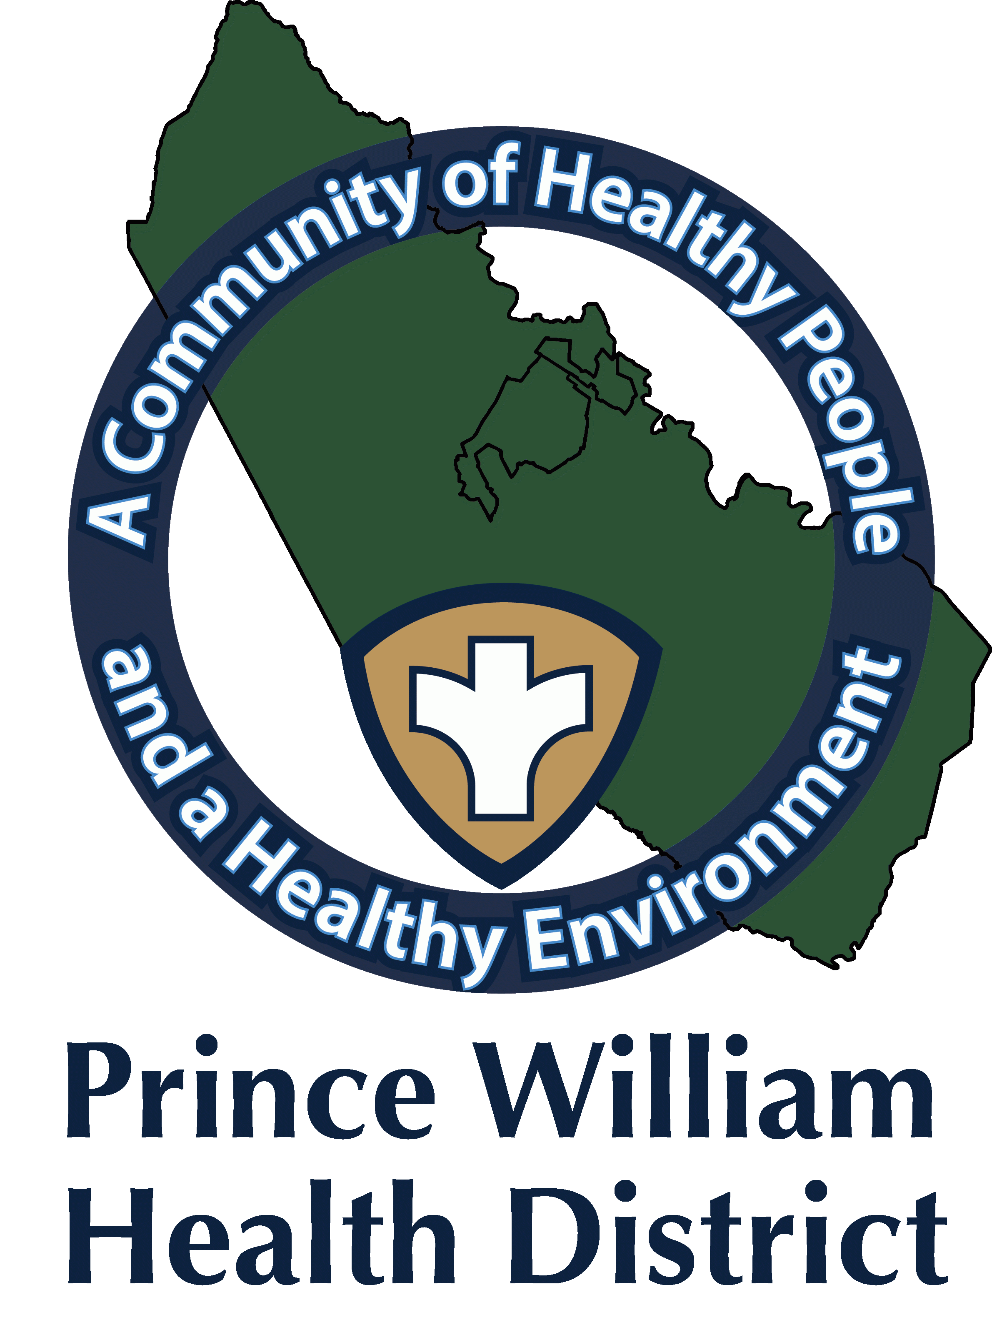

Information Update
Community Outreach Director
Sean Johnson
Sean.johnson@vdh.virginia.gov
November 8, 2021

The Prince William Health District What You Should Know:

How you can Protect Yourself and Your Loved Ones During the Holidays

PWHD would like to remind all community members to protect themselves and their loved ones from COVID and other communicable diseases going into the holiday season. While great gains have been made towards ending the pandemic, it is not yet over.

As of November 1, national and local case rates were similar to what they were at the same time last year, and statewide case rates are slightly higher than prior to the holiday surge of last year.

Together we can lower COVID rates and prevent another surge over the holiday season, as well as take us one step closer to ending the pandemic.

Each community member is reminded to consider the following strategies:
- Get vaccinated and get a booster or third shot, if eligible. They're free, safe, and effective at protecting you and your loved ones
- Wear a mask when in public and indoors. It protects you from both COVID and other diseases and allows you to resume more normal activities in a safer manner
- If you are sick, stay home and get tested for COVID. If you are exposed to someone with COVID, stay home and seek testing immediately after your exposure
- If the health department calls, talk to us. We are here to help, judgement free!
- Weather permitting, move any gatherings with friends and families outdoors. Better ventilation means a lower risk of disease spread.
- The week before any gatherings, take enhanced precautions and encourage your family to do so as well to lower the chance of a COVID outbreak at your gathering. These precautions include:
- Avoiding non-essential travel
- Avoiding crowded events/venues
- Wearing a mask indoors if 2 years old or older
- Closely monitoring for any symptoms.
- Encourage your family members to get vaccinated now to protect the family for the holidays.

Community Vaccination Center and Manassas Mall Clinic
Appointments for adolescents and adults are highly recommended. Appointments are required for 5–11-year-olds.
Sign up for appointments at vase.vdh.virginia.gov for either the CVC or the Manassas Mall vaccine clinic
Community Vaccination Center (CVC)
- The Prince William CVC is located at the old Gander Mt. building, which is located at ​​14011 Worth Avenue, Woodbridge, VA 22192.
- The CVC will offer vaccines for ages 5-11, by appointment only at this time.
- The CVC is open Tuesday through Sunday from 10 a.m. to 7:30 p.m.

Manassas Mall Clinic
- PWHD Manassas Mall COVID-19 vaccine clinic is located 8300 Sudley Rd, Manassas, VA 20109
- At Manassas Mall, vaccines for 5–11-year-olds will be offered Mondays, Tuesdays, Wednesdays, Thursdays, and Saturdays, by appointment only.

Mall Clinic Hours:
- Mondays: 12 p.m. to 4 p.m. (walk-ins accepted for 12 years and older, vaccines offered: Pfizer, and Moderna). By appointment only, Pfizer 5–11-year-old vaccinations. The Flu vaccine will be offered while supplies last.

- Tuesdays: 11 a.m. to 6 p.m. (clinic closed 2:30 p.m. to 3:00 p.m., walk-ins accepted for 12 years and older from 1:00 p.m. to 2:30 p.m., vaccines offered: Pfizer, Moderna, Johnson & Johnson). By appointment only Pfizer 5–11-year-old vaccinations.

- Wednesdays: 11 a.m. to 6 p.m. (clinic closed 2:30 p.m. to 3:00 p.m., walk-ins accepted for 12 years and older from 1:00 p.m. to 2:30 p.m., vaccines offered: Pfizer, Moderna, Johnson & Johnson). By appointment only Pfizer 5–11-year-old vaccinations.

- Thursdays: 11 a.m. to 6 p.m. (clinic closed 2:30 p.m. to 3:00 p.m., walk-ins accepted for 12 years and older from 1:00 pm to 2:30 pm, vaccines offered: Pfizer, Moderna, Johnson & Johnson). By appointment only Pfizer 5–11-year-old vaccinations.

- Fridays: 12 p.m. to 4 p.m. (walk-ins accepted for 12 years and older, vaccines offered: Pfizer, and Moderna). The Flu vaccine will be offered while supplies last. No 5–11-year-old vaccinations on Fridays.

- Saturdays: 9 a.m. to 5 p.m. (clinic closed 12:30 p.m. -1:00 p.m., walk-ins accepted for 12 years and older from 1:00 p.m. to 2:30 p.m., vaccines offered: Pfizer, Moderna, Johnson & Johnson). By appointment only Pfizer 5–11-year-old vaccinations.

Mobile Clinic Unit

- Tuesday, November 9, from 11:30 a.m.- 5:30 p.m.
- Americana Grocery, 14428 Jefferson Davis Hwy., Woodbridge VA. 22191
- First, second, third doses, and for those eligible for the Pfizer-BioNTech, Moderna, and Johnson & Johnson Booster dose.
- COVID-19 Vaccines Pfizer (for 12 and older) Johnson and Johnson (18 and older). Pfizer 5–11-year-old vaccinations offered while supplies last.
- The Flu vaccine will be offered while supplies last.
- No appointments are required. Walk-ins are accepted if supplies last. Weather permitting.

- Thursday, November 11, from 11:30 a.m.- 5:30 p.m.
- 7-Eleven, 9166 Mathis Ave., Manassas VA., 20110
- First, second, third doses, and for those eligible for the Pfizer-BioNTech, Moderna, and Johnson & Johnson Booster dose.
- COVID-19 Vaccines Pfizer (for 12 and older) Johnson and Johnson (18 and older). Pfizer 5–11-year-old vaccinations offered while supplies last.
- The Flu vaccine will be offered while supplies last.
- No appointments are required. Walk-ins are accepted if supplies last. Weather permitting.

