REGIONAL APPROACH TO GLASS RECYCLING LEADS TO CREATION OF THE PURPLE CAN CLUB
Thursday, 11 Apr 2019

Public Works / Solid Waste Management

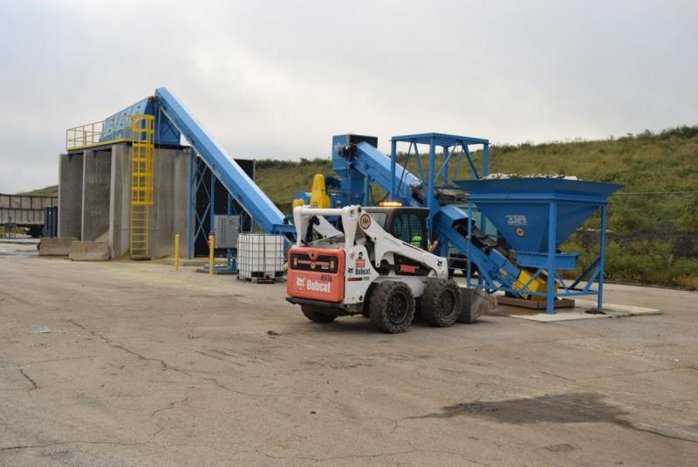
Big Blue crushes glass into sand and gravel for use in a variety of projects.
Today (4-11-19), Fairfax County, City of Alexandria, Prince William County, and Arlington County announced a new strategic partnership to recover and recycle glass. In Northern Virginia, glass collected in curbside recycling bins is sent to recycling facilities where it eventually ends up in landfills. During the transportation process to the facility glass is broken and becomes mixed with recycling residue (small bits of plastic and paper) as part of the sorting process, making it unrecoverable. To tackle this challenge, these jurisdictions have committed to collecting glass via purple glass-only drop-off containers and bringing it to Fairfax County’s “Big Blue” processing plant, where it will be recycled for use in a variety of projects. Read more about the region's Purple Can Club creation.

