Prince William County

Community Criminal Justice Board
January 27, 2021

PRESENT: Brad Marshall, Leviticus Bass, Keith Nguyen, Tara Moore-Petty, Antonio Bryer, Peter Meletis, Robert Gudz, Peggy Anthony, Jeff Homan, Tom Garrity, Tracey Lenox, Dan Manza, Anthony Kostelecky for Amy Ashworth, Judge Robert Coleman, Kerry Davis, Terry Fearnley, Judge Lisa Baird, Rebecca Sutter, Carl Dorr

ABSENT: Devan Kirk, Judge Steven Smith, Jacqueline Sott, Jennifer Braswell-Geller, Judge Tracy Hudson,

STAFF: Steve Austin, Tomaudrie Thomas, LaToya Morton, Cassie Wright, Natalie Benitez

CITIZENS: None

GUESTS: None

CALL TO ORDER: 5:01 pm

CHAIRPERSON’S COMMENTS (Item 1)

Introduced new CCJB member Robert Keller, he is the new CCJB Citizen Member Representing the City of Manassas.
Resolution Finding the Need to Conduct the January 26, 2021, Community Criminal Justice Board Meeting Electronically (Item 2)

Chairperson Brad Marshall asked for a motion to approve the virtual meeting. The motion was made by Anthony Kostelecky and seconded by Jeff Homan. The motion was passed unanimously.

APPROVAL OF AGENDA (Item 3)

Chairperson Brad Marshall asked for a motion to approve the agenda. The motion was made by Thomas Garrity and seconded by Anthony Kostelecky. The motion was passed unanimously.

APPROVAL OF MINUTES (OCTOBER 27, 2020 (Item 4)

Chairperson Brad Marshall asked for a motion to approve the meeting minutes. The motion was made by Anthony Kostelecky and seconded by Peter Meletis. The motion was passed unanimously.

CITIZENS TIME (ITEM 5)

Chairperson Brad Marshall asked if there were any citizens present. There were no citizens present.

MASON AND PARTNERS (MAP) CLINICS (ITEM 6)
Dr. Rebecca Sutter - stated that Mason and Partners (MAP) started providing healthcare services in the Manassas Park area in 2013. The Mason and Partners (MAP) clinics have two main goals: 1.) To provide interprofessional practice sites in community-based settings to serve as student clinical/field experiences; and 2.) To increase access to free/low-cost primary healthcare to most vulnerable patients in the communities. Mason and Partners (MAP) clinics provide a full range of health services, including acute primary care, integrated behavioral health and substance abuse services (MAT-OBOT), health promotion, and disease prevention to low-income, uninsured and risk populations. The clinics reduce health disparities by providing accessible, high-quality, comprehensive medical and behavioral health care to populations that have significant challenges accessing care.
The Mason and Partners (MAP) clinics partner with Virginia State and local health departments, Department of Social Services, Non-Government Organization (NGO), foundations, faith-based organizations, criminal justice partners, local community advocates, and residents in the community.
There has been an increase in fatal opioid during the onset of the Covid-19 pandemic. Mason and Partners (MAP) are working with other community-based services and organizations to help reduce these numbers. Cross-Sector Collaboration: Empowered Community Opioid Project (ECOP) has allowed Mason and Partners (MAP), Virginia State, Health and Human Services and the Criminal Justice systems to work together on community-based services.
The Covid-19 pandemic has brought a rapid expansion of care delivered via telehealth. This has allowed Mason and Partners (MAP) clinics to provide continued healthcare services to underserved patients during this time, while simultaneously offering valuable student clinical services.
Masons and Partners (MAP) have added value to the community and partners by technical and research expertise using unique models of care, helping community health with access to health and disease management services, assessments of current health status and future health risks for communities, and helping citizens prepare for the workforce post-graduation. The clinics provide a monetary value of $200,000 per month for services offered to uninsured/underinsured patients in Prince William County. The page below are the locations for the Mason and Partners (MAP) clinics.
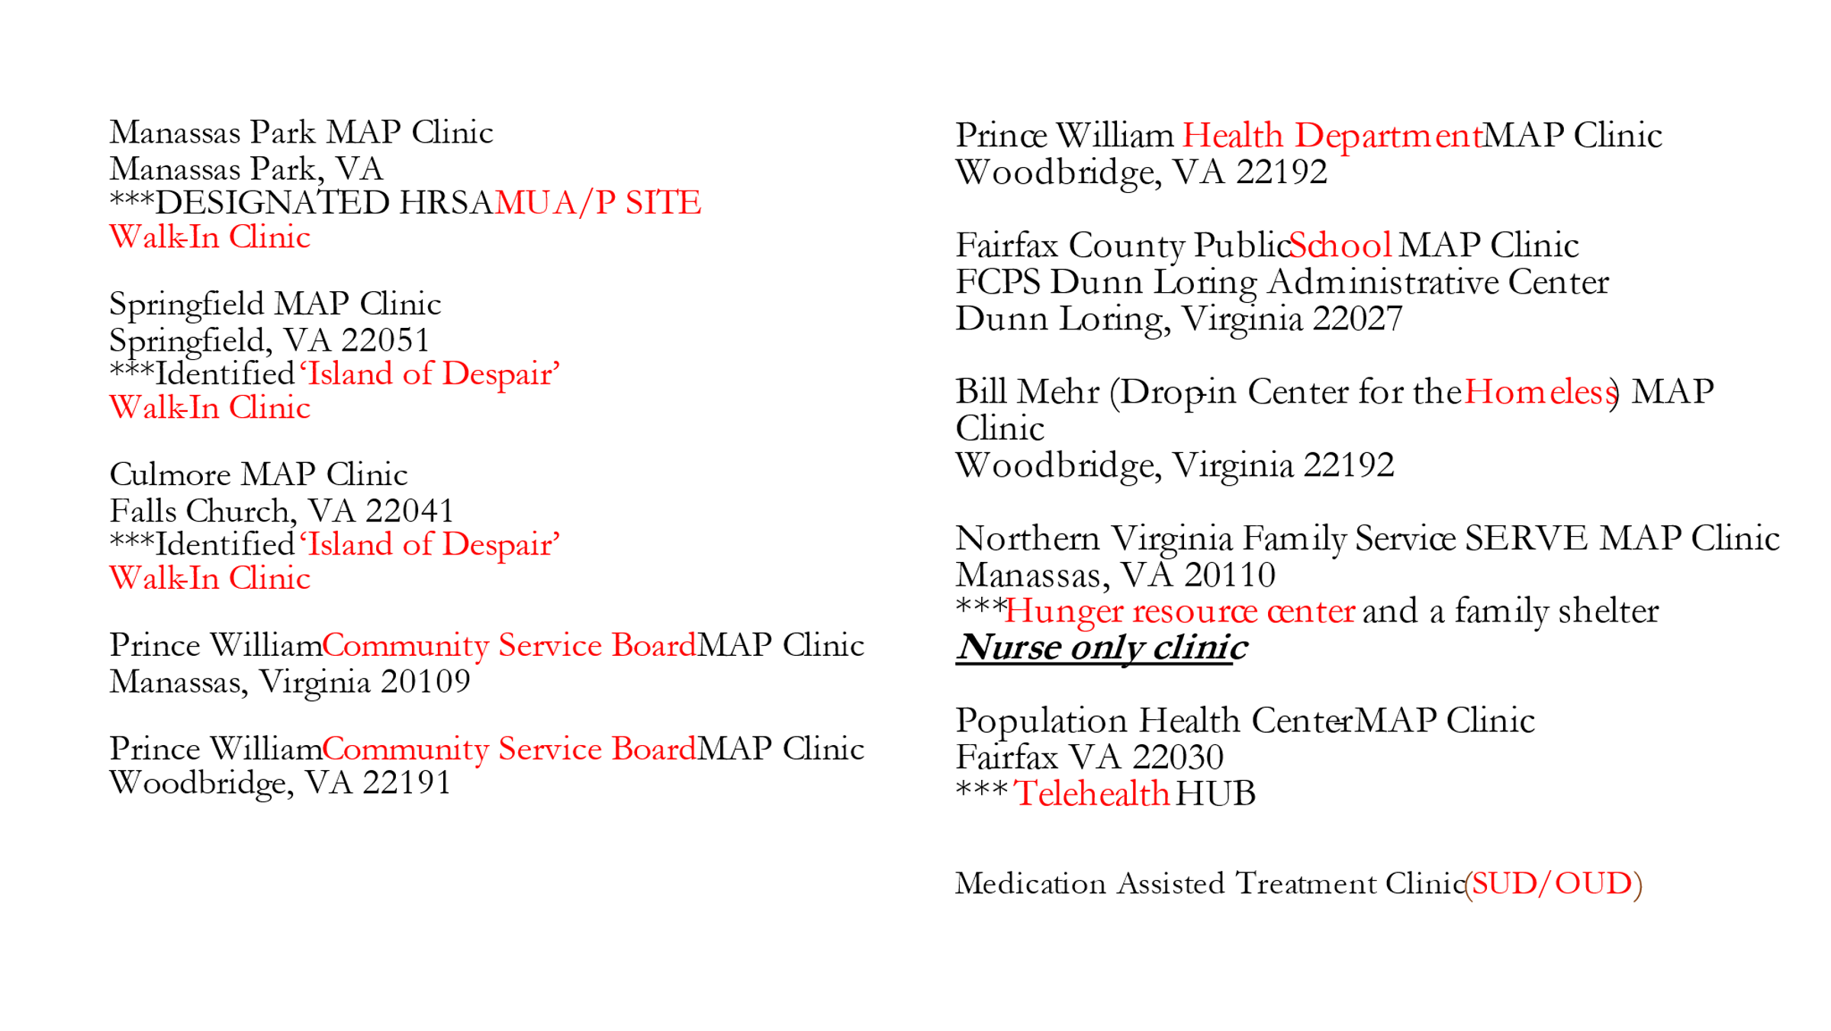
EVIDENCE BASED DECISION MAKING UPDATED (EBDM) (ITEM 7)
Steve Austin - announced the Evidence Based Decision Making (EBDM) Team has been meeting virtually with a few subcommittees. Evidence Based Decision Making (EBDM) and the Opioid subcommittee plan to develop more activities to include Peer and medication assistance treatment. The Mental Health subcommittee is focusing on developing a new mental health work plan by updating the system map to identify gaps in services for individuals who are mentally ill. The subcommittee will invite a facilitator to assist with this process and review data in order to give assistance with closing the gaps.
DCJS QUARTERLY REPORT (ITEM 8)
Tomaudrie Thomas - presented the pretrial statistics for 2nd quarter FY21 (October 2020 -December 2020). The statistics show 1,241 defendants have been interviewed for pretrial prior to arraignments through December 2020. The court concurrence rate with pretrial recommendations is 65%. The clients that are placed on pretrial supervision have a 76% rate of being released on a recognizance or an unsecured bond. The pretrial placement numbers show that there are 872 new pretrial supervision cases. The pretrial court appearance rate is 92% for those individuals that get to court successfully, and the public safety rate is 96% which is the rate that individuals do not receive new charges. The Intensive Community Supervision Program monitors individuals that are higher risk, and this program has saved 4,851 jail bed days between October 2020 and December 2020.
Local Offender Probation data show that there have been 436 placements through December 2020 and 89% of those placements are for misdemeanor offenses and 11% are for felony offenses. The success rate for Local Offender Probation is 84% for misdemeanor offenses and 80% for felony offenses.
CCJB MEETING SCHEDULE (ITEM 9)
Brad Marshall - announced that the next CCJB Meeting will be Tuesday April 27th, 2021 at 5:00 p.m. The location will be determined based upon in person or a virtual meeting. The following meeting dates will be July 27th, 2021 at 5:00p.m., and October 26th, 2021 at 5:00p.m.
Steve Austin - announced that the calendar was placed on the agenda because there is a vacancy for county government that has not been filed since Tracy Gordon was a representative. The CCJB meeting conflicts with the Board of County Supervisors meetings so a suggestion was made to address possibly changing CCJB meeting dates.
Bradley Marshall - announced to keep the April 27, 2021, CCJB meeting date and he will follow up with Steve Austin of any additional changes in dates with scheduling to accommodate Prince William County as well as Manassas City and Manassas Park.
ROUND TABLE TOPICS (ITEM 10)
Anthony Kostelecky - announced the Commonwealth Attorney’s office is continuing to balance public safety and are letting individuals out on pretrial. He would also like to commend the jail for how they have been handling inmates during Covid-19.
Antonio Bryer - announced that he is with Prince William County Schools and the attendance for in person contact has been pushed back for middle school and high school students until the end of February or early March.
Daniel Manza - stated that he is with Community Services Board and Drug Offender Recovery Services (DORS). He is currently working on the Medication Assisted Treatment Program with the jail.
Jeffrey Homan - stated that he is the Director with 31st District Court Services Unit. The Joint Legislative Audit and Review Commission (JLARC) and General Assembly has been authorized to review the entire Juvenile Detention System within this year. They will evaluate processes and court service units around the state.
Peggy Anthony - announced that she is with District 35, Probation and Parole. Prince William County received a Project Safe Neighborhood achievement award from the Department of Justice. It was under the category of Innovative Prevention and Re-entry Strategy.
Peter Meletis - announced that he wanted to give an update on Covid-19. The Adult Detention Center currently has 7 staff members and 11 inmates that are positive with Covid-19. Due to Covid-19, Rappahannock Regional Jail is currently locked down due to having a COVID-19 outbreak. The Department of Corrections currently have 1400 inmates that are positive for COVID-19. Other than Covid-19 issues, the jail is currently working on a project dealing with opioid users and how to assist with delivering medication.
Judge Robert Coleman - announced that he is in the General District Court. The dockets continue to be segmented for public safety reasons however, cases are being heard on a frequent basis.
Steve Austin - announced that he is the Director for Criminal Justice Services. Criminal Justice Services have been maintaining contact with clients, ensuring public safety and pretrial numbers have increased significantly. The Adult Detention Center transferred 3 positions in the fall of 2020 to Criminal Justice Services for assistance with pretrial services. The General Assembly approved in last year’s budget pretrial services to be expanded to some rural areas in Virginia as well as Community Based Probation. Those expanded areas are in jurisdictions across the state. Legislation that has been proposed by Senator Creigh Deeds, to eliminate rebuttable presumption offenses. A Bill being reviewed is a Pretrial Data Transparency Bill (HB2110) by Delegate Herring who is Chair of the Crime Commission, and this bill is focused on requiring data elements on arrests and crime to be collected at the pretrial stage. Another relevant bill is HB2286 requires counsel at first appearance.
Thomas Garrity - announced that Monday February 1, 2021 will be the swearing in of the new Chief of Police Peter Newsham.
Tracey Lenox - announced she is with the Public Defenders Office. The Public Defender’s Office is moving forward with trying to receive access to allow clients to get on dockets faster and having contact with clients the next day. The Public Defenders Office will be reviewing a way to work with the jail as well as the courts to complete this process.
Brad Marshall - announced that he represents the County Bar Association and he wanted to thank the Judges, Commonwealth Attorneys, Public Defenders, ADC, Sherriff’s Department, Law Enforcement Agencies, DCJS, DSB, CJS, Court Services, Probation and Parole, as well as the court clerks. The General Assembly has a bond statute to eliminate mandatory minimums that could affect bond and pretrial issues. The legalization of marijuana will cause an effect as well as those that have mental health issues. The members should notify Brad Marshall or Steve Austin of any other bills that need to be reviewed before the next meeting.
Adjournment (Item 11)
Chairperson Brad Marshall asked for a motion to adjourn the meeting. The motion was made by Peggy Anthony and seconded by Tracey Lenox. The motion was passed unanimously, and the meeting was adjourned at 6:00 p.m.

Next Meeting: April 27, 2021
Location: TBD
5:00 p.m.

