Prince William County

Community Criminal Justice Board
October 27, 2020

PRESENT: Leviticus Bass, Brad Marshall, Devan Kirk, Keith Nguyen, Tara Moore-Petty, Antonio Bryer, Peter Meletis, Robert Gudz, Peggy Anthony, Ellen Patterson for Jeff Homan, Tom Garrity, Tracey Lenox, Dan Manza, Anthony Kostelecky for Amy Ashworth, Judge Robert Coleman, Kerry Davis, Terry Fearnley

ABSENT: Judge Lisa Baird, Judge Carroll Weimer, Jacqueline Sott, Jennifer Braswell-Geller, Judge Tracy Hudson,

STAFF: Steve Austin, Tomaudrie Thomas, LaToya Morton, Cassie Wright

CITIZENS: None

GUESTS: None

CALL TO ORDER: 5:02 pm

CHAIRPERSON’S COMMENTS (Item 1)

Peggy Anthony announced that she would like to welcome our new member Dan Manza of Community Services who will be joining our group in place of Sara Wheeler who was recently promoted at Community Services.

APPROVAL OF AGENDA (Item 2)

Vice Chairperson Peggy Anthony asked for a motion to approve the agenda. The motion was made by D. Brad Marshall and seconded Judge Robert Coleman. The motion was passed unanimously.

APPROVAL OF MINUTES (July 28, 2020 Item 3)

Vice Chairperson Peggy Anthony asked for a motion to approve the July 28, 2020 meeting minutes. The motion was made by D. Brad Marshall and seconded by Judge Robert Coleman. The motion was passed unanimously.

CITIZEN’S TIME (Item 4)

Vice Chairperson Peggy Anthony asked if there were any citizens present. There were no citizens present.

Appointment of nominating committee to select Chair/Vice Chairperson (Item 5)
Peggy Anthony thanked Steve Austin and Tracey Lenox for their help with the nominating committee. The first nomination for the Chair is Brad Marshall and it was the only nomination for this position. The vote was unanimous for Brad Marshall for the position of Chair. The second position was Vice Chair and Peter Meletis was the only nomination for this position. The vote was unanimous for Peter Meletis for the position of Vice-Chair. Peggy Anthony thanked everyone for the opportunity for her to serve in the position of Vice Chair. Brad Marshall took over for the remainder of the meeting as Chair.

2020 Edward Byrne Memorial Justice Assistance Grant (JAG), Department of Justice (Item 6)

Tom Garrity announced that the Police Department is applying for a grant for forensic items. The first request is a digital printer because the jury, judges, commonwealth attorneys and defense attorneys would all like high quality pictures. The second request is for high quality cameras because the current cameras are not high resolution, and the life span does not last long. The next request is for Superglue Chamber which has short processing time, it increases efficiency and capacity through expanding equipment functionality, and improving quality of output sessions, as well as evidentiary photographs and fingerprints. The Superglue helps with blood evidence on clothes and sheets to be analyzed and stored. It is used on cars that have fingerprints and on areas that are not smooth. The total cost for this will be $98,000 dollars.

Virginia Community Criminal Justice Association Pretrial Forums (Item 7)

Steve Austin gave information about how a pretrial forum that was done this fall by the Virginia Community Criminal Justice Association (VCCJA) to influence pretrial justice and policy in Virginia. VCCJA did the forum to give input and information to policy makers as the result of previous bills in the General Assembly that were not passed but have resulted in a long-term study of pretrial services and the pretrial justice system in Virginia by the Virginia State Crime Commission. The forum was in two parts, the first forum was in September that included pretrial advocates discussing Virginia’s Pretrial Justice System and what has been happening nationally. Alec Karakatsanis presented and is the founder of The Civil Rights Corps which is a civil rights advocacy group in D.C; that has been challenging pretrial systems across the country. He has challenged many aspects such as inmates being incarcerated at the pretrial stage for long periods of time for minor misdemeanor offenses. Kim Rolla is the Interim Director of Legal Aid Justice Center’s Civil Rights and Racial Justice Program in Charlottesville and discussed legislative advocacy in Virginia. Christopher Rashad Green was also a forum presenter and works with an advocacy organization, the New Virginia Majority, which has conducted a court watch program that has been monitoring pretrial practices in Virginia Courts and he is also a speaker on equity and justice. The second forum was in October and focused on various pretrial justice reforms from other states and in Virginia. Mark Levin presented and is with the Texas Public Policy Foundation. This foundation has done work regarding the Criminal Justice System reforms from a fiscal perspective including analyzing the costs of running the Criminal Justice Systems including detaining at the pretrial stage and its impacts on communities. Tim Martin is the Commonwealth Attorney’s in Augusta County who spoke about a Pretrial Diversion Program in place in their community that came from Evidence Based Decision Making (EBDM) Initiative that is diverting lower-level defenders. Brian Kennedy is a Public Defender in Fairfax and the Policy Director for Justice for Virginia, which is doing advocacy on pretrial systems and criminal system reform. The forums are now posted on YouTube and are each 90 minutes long. Steve Austin will provide a link to those forums for viewing purposes.

Evidence Based Decision Making (EBDM) Update & EBDM Data Update (Item 8)

Steve Austin announced that the Evidence Based Decision Making is a framework for making informed and research driven decisions in the Criminal Justice System. The team began in 2015 and the motivation was the expansion of the Adult Detention Center. The National Institute of Corrections initiated the Technical Systems Grant and EBDM applied for it and received the funding. The purpose of EBDM is to reduce harm, provide greater consistency in criminal justice outcomes, safely manage the jail population, and realign resources in the criminal justice system when possible. A stakeholder group was put together with judges, commonwealth attorney, court clerks, public defenders, magistrates, law enforcement, state probation, community services, city/county governments, community corrections and pretrial services. Since the group began, George Mason University and the Virginia Department of Health has been added to the EBDM team. EBDM is about collecting data, understanding data, and how it impacts the system. In the five years of this initiative, programs and processes have been implemented to try to improve the criminal justice system. There was initially a mapping done to look at the system from the beginning to the end at the various decision points. This process also identified strengths as well as gaps within the criminal justice system. Some processes were easy to fix such as double dating court dates in order not to avoid confusion which caused defendants to fail to appear. The bigger initiatives included risk assessments, mental health initiatives, veterans docket, and addressing probation violations. The pretrial risk assessment was updated through a state initiative by changing the process for recommendations for release and updating the risk assessment tool. The Police Department implemented the PROXY which is a risk assessment tool to assist the police in making decisions regarding summons or custodial arrest.

Cassie Wright stated that there are multiple components to the EBDM framework. The first item discussed was Reducing Harm and Increasing Public Safety. Recidivism rates for local offender probation, 3 years after termination from probation has been at 26% for 2018 and 23% for 2019 and 2020. While the current goal is 20% or lower, this is an ambitious goal and is well under national probation recidivism outcomes.

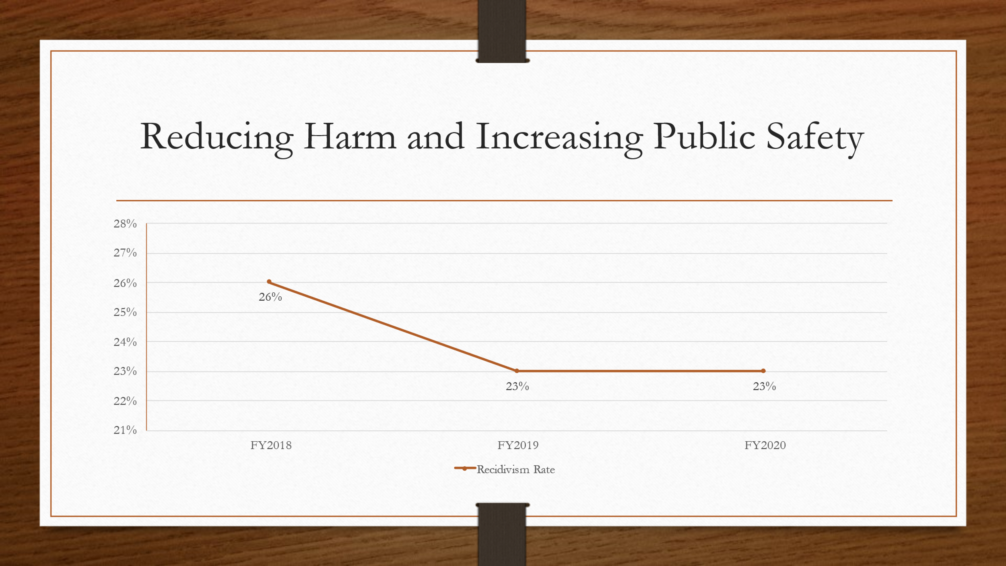

The next item discussed was the pretrial population. The left chart below shows the success rate of court appearances for clients and that is the percentage of defendants in which the bonds are not revoked for failing to appear at court. The chart on the right shows the public safety rate which is the percentage of defendants whose bond is not revoked for obtaining new criminal charges while they are on pretrial supervision. Over the past 5 years these number have been have remained over a 90% success rate for public safety.

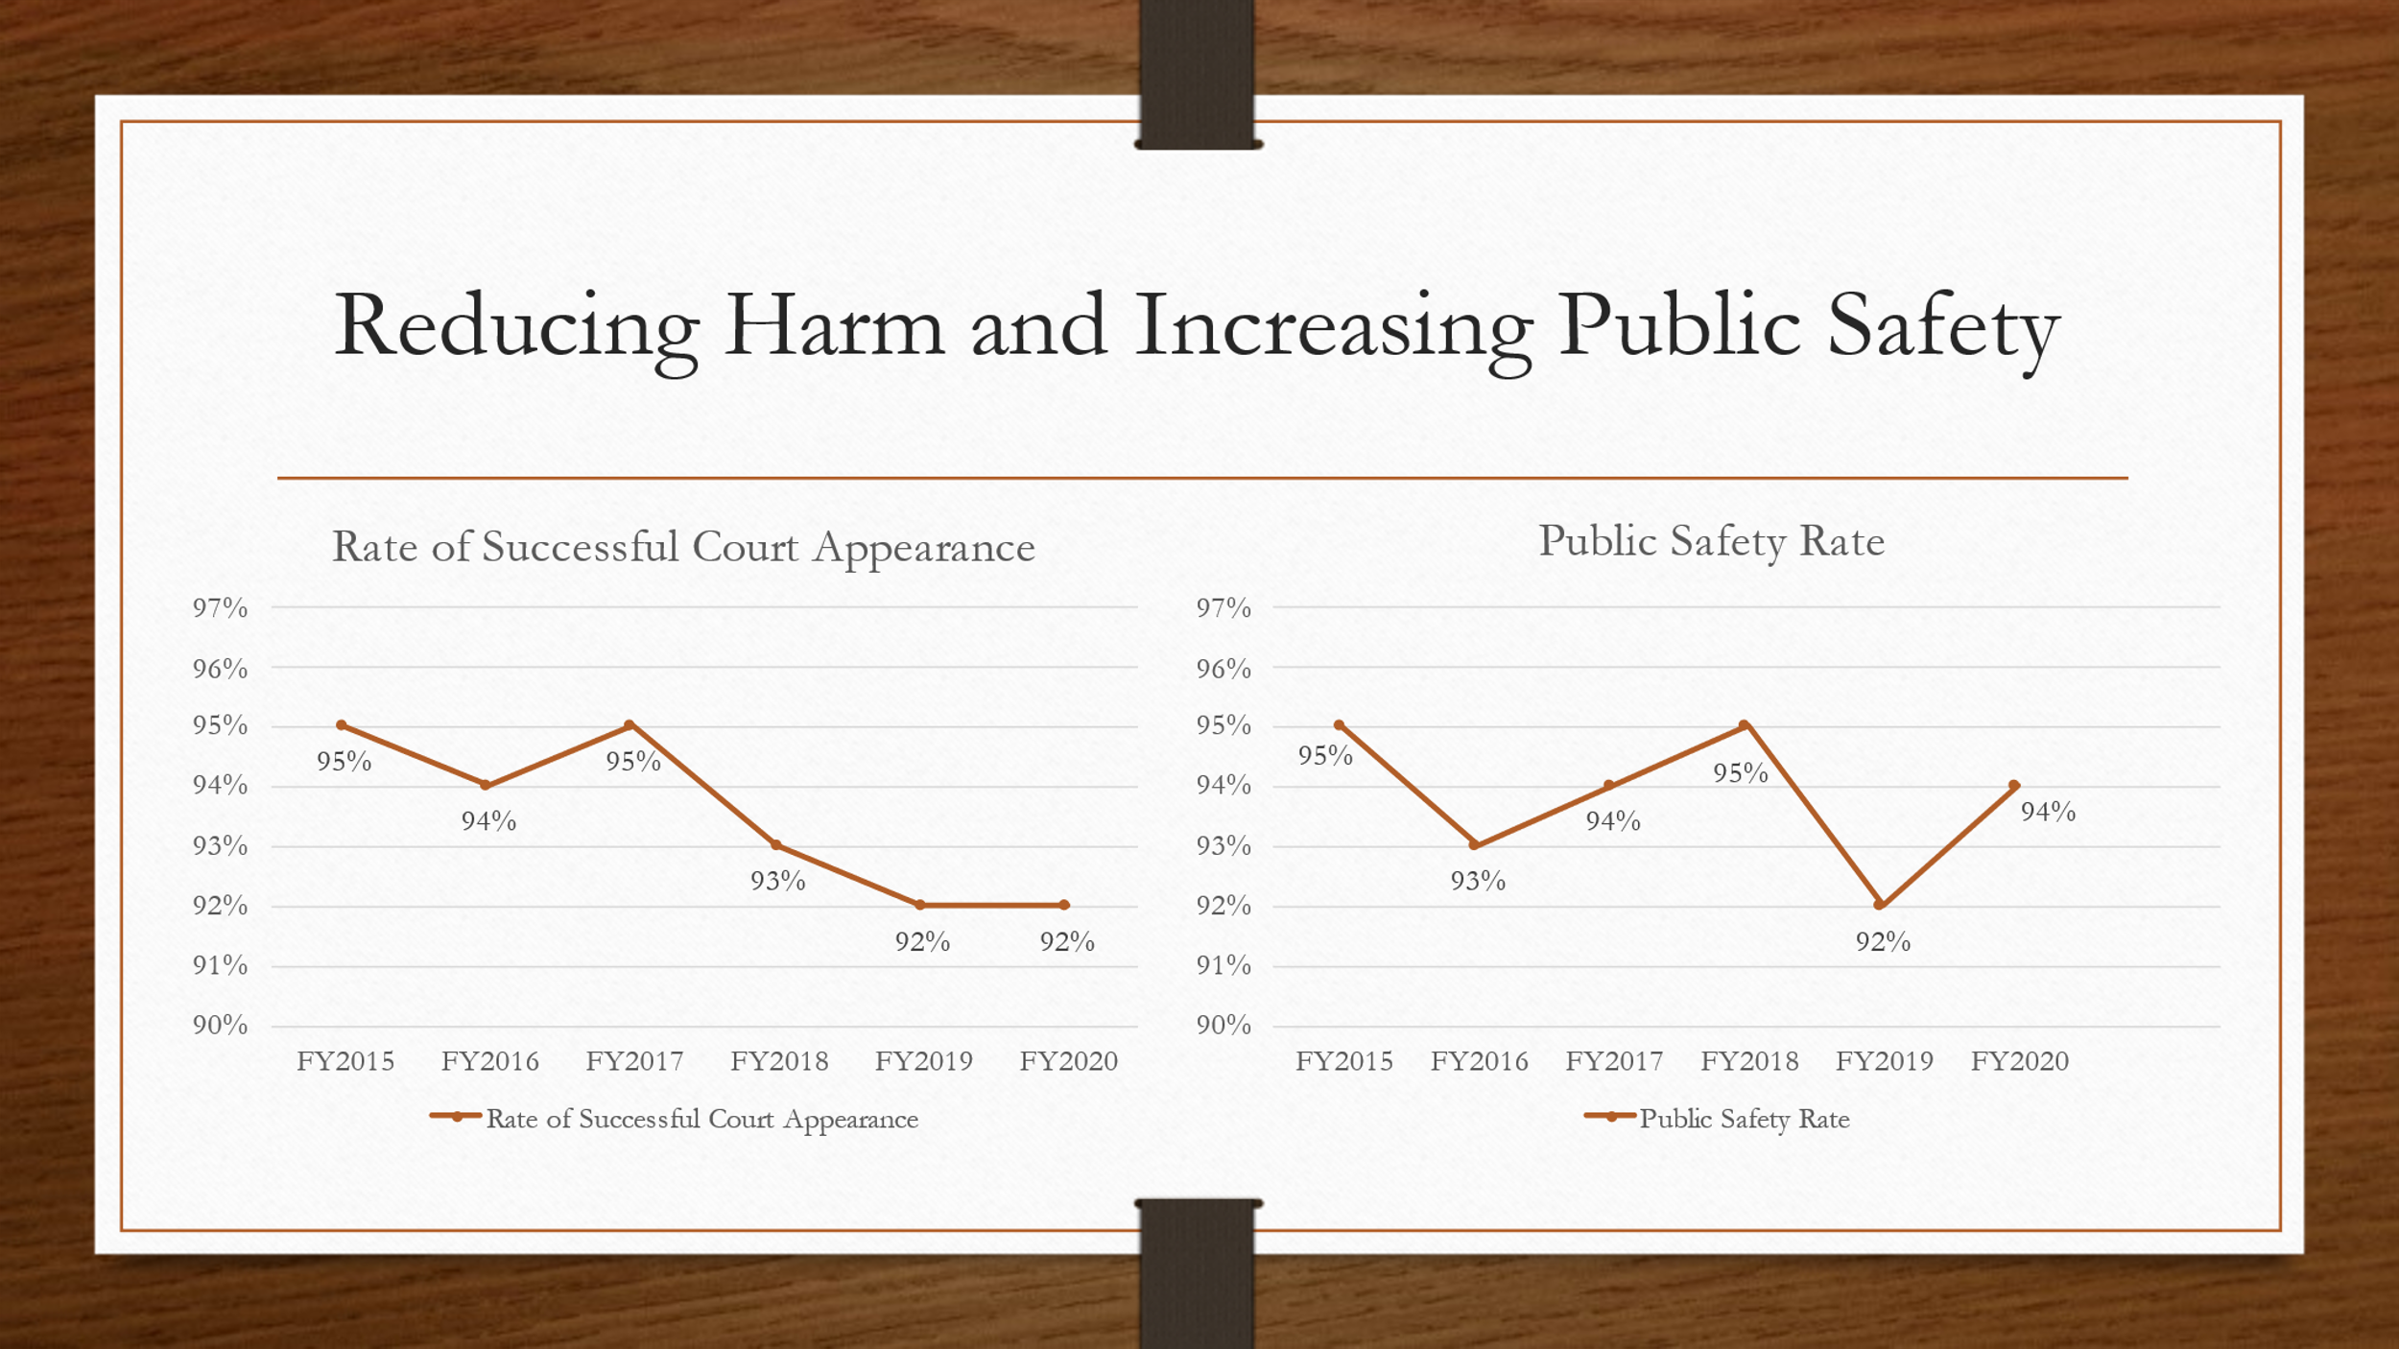

The next chart shown below is court decisions regarding bond types at defendant’s initial arraignment hearings. The highest percentage rate appears to be the denial of bail; however, secured bonds have been decreasing and unsecured bonds have been increasing.

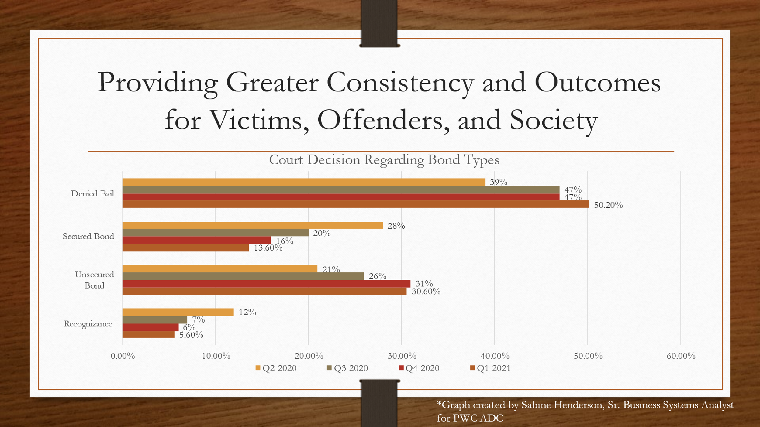

The next charts below are also for pretrial clients in Prince William County. The graph on the left shows the risk levels for defendants that are placed on pretrial supervision. The graph on the right shows the percentage of inmates that are in the Adult Detention Center awaiting trial and have not been place on pretrial supervision. Based on the risk levels 1 thru 6, most clients placed on pretrial supervision are medium risk. The lowest percentage of defendants that are placed on pretrial are the highest risk. COVID-19 caused a huge push to get defendants out of jail which contributed to a large decrease in the ADC awaiting trial population during Q3 2020. Over time more than 40% of inmates in jail are still on pretrial status awaiting trial.
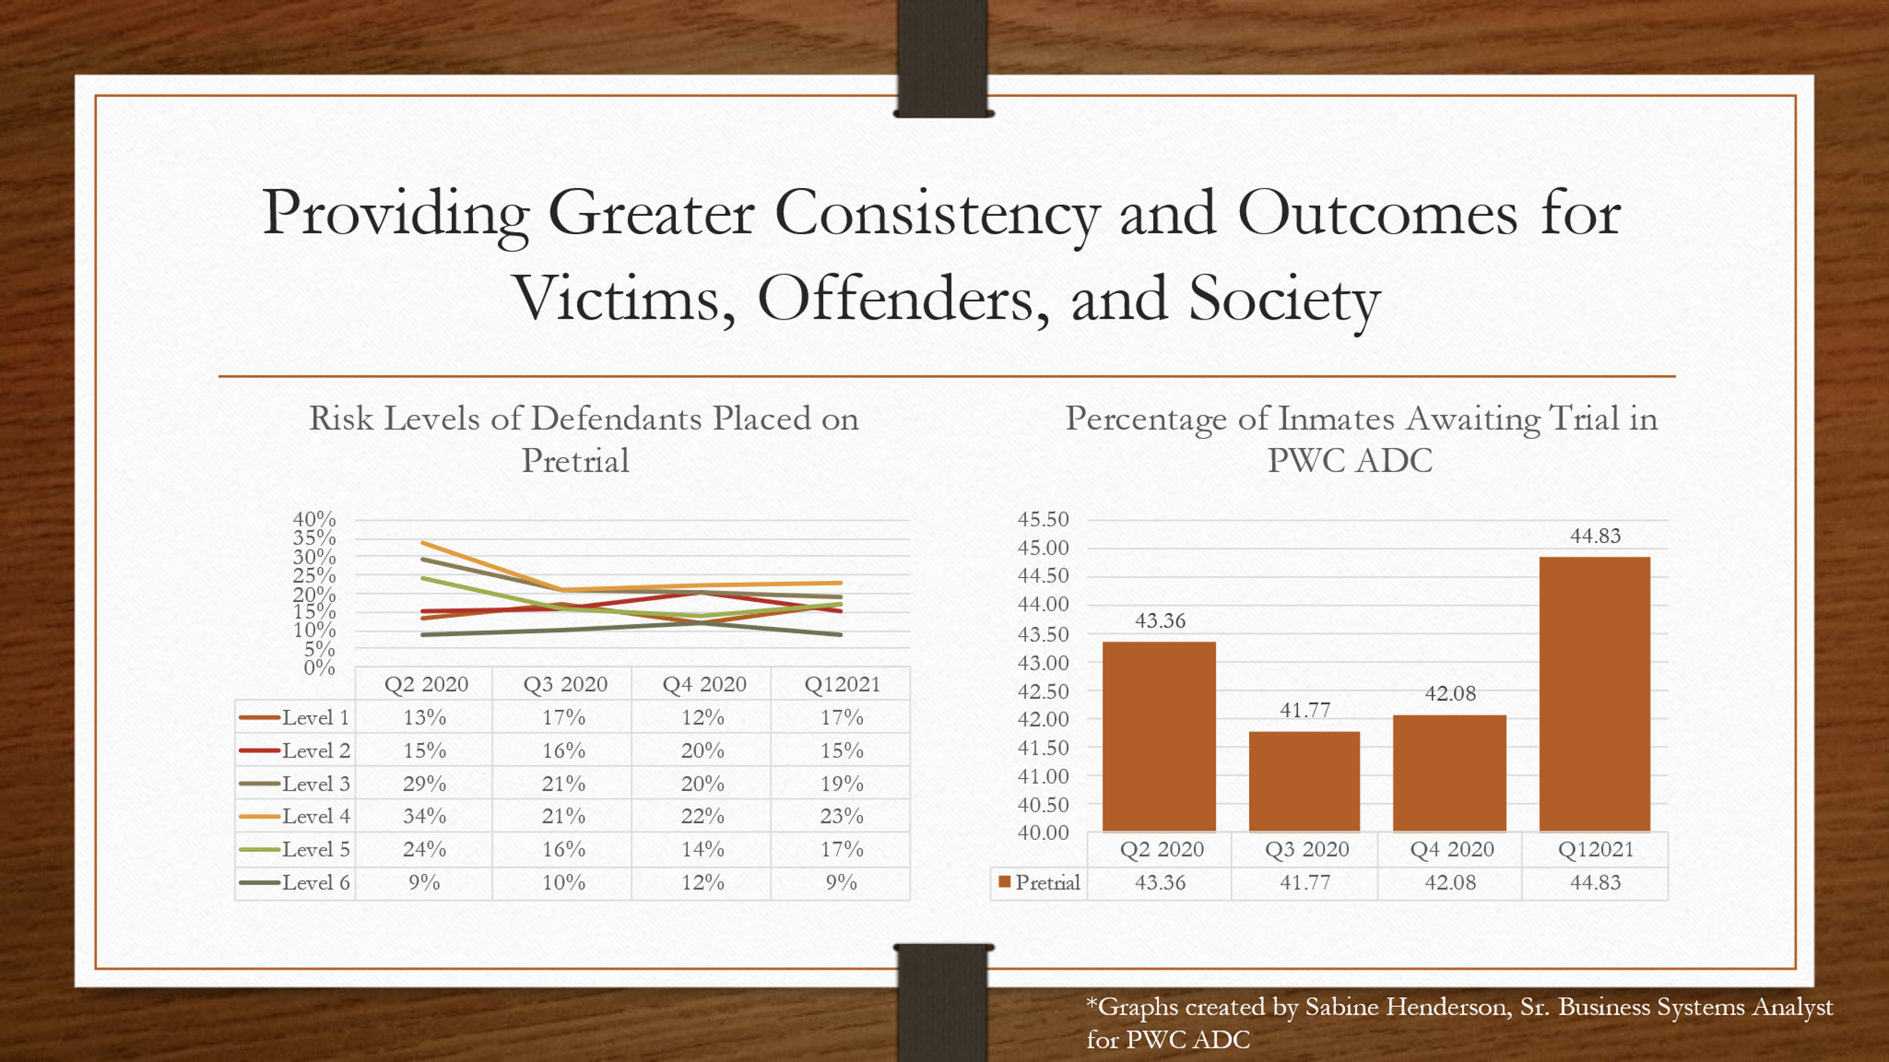

The next graph shows the increase in jail population and the pretrial population over the past 5 years. There is a decrease in jail population by 30% between the years of 2015 and 2020. In Criminal Justice Services there is an increase of 120% of pretrial clients between 2015 and 2020. Although Criminal Justice Services caseload has increased, successful court appearances and public safety rates have been maintained.

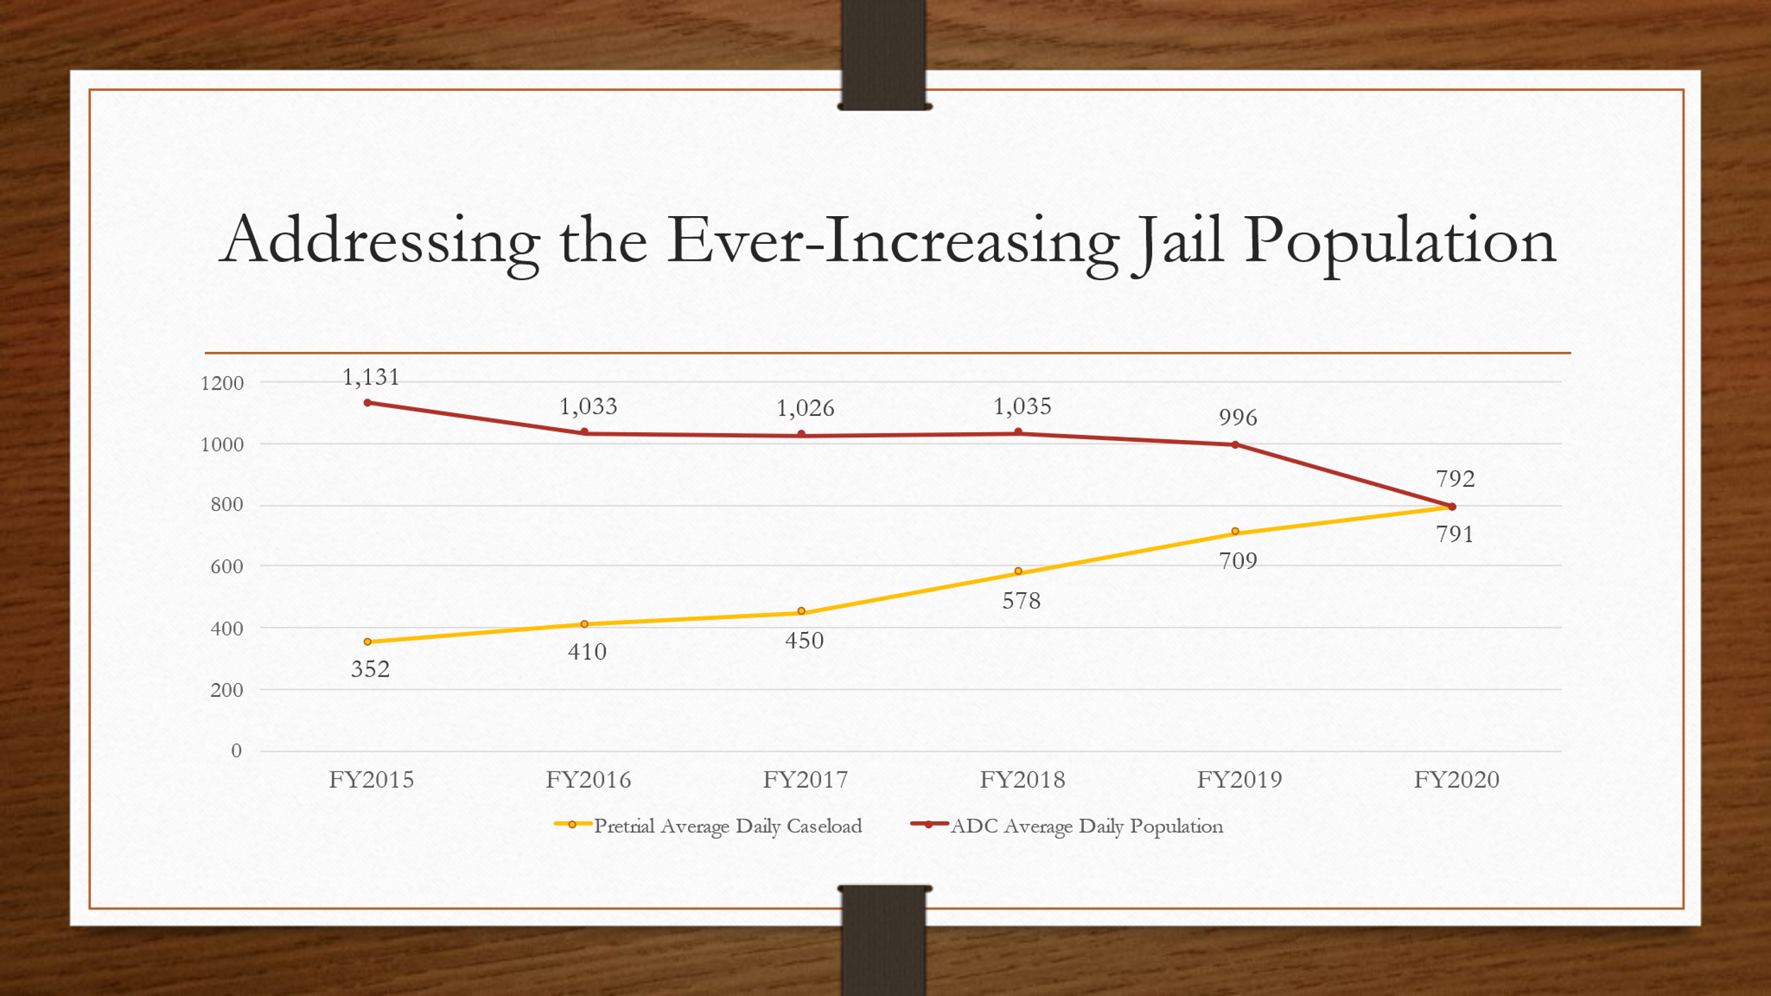
The last graph is Realigning and Optimizing the Allocation of Resources. There were multiple position shifts from the Adult Detention Center to Criminal Justice Services due to the jail population decreasing and the caseload of Criminal Justice Services increasing. In fiscal year 2020, Criminal Justice Services received 3 positions and at the end of fiscal year 2019 there was a deficit of two pretrial officers. At the end of 2020 there were over 1200 active cases on pretrial. There were 3 additional positions approved for fiscal year 2021.

DCJS Quarterly Reports (Item 9)

Tomaudrie Thomas stated that stats for Criminal Justice Services Pretrial Services are exceptional due to court decisions rates being 68% consistent with staff recommendations. When Evidence Based Decision Making first began, that rate was only about 38%. The updated risk assessment instrument and communication throughout all the agencies that participated helped increase this rate. The recognizance and unsecured release conditions equates to 74% that are released to Criminal Justice Services. This first quarter for the fiscal year has a 91% court appearance rate which means those clients make it court successfully. The public safety rate which is avoiding a new arrest while on pretrial supervision 96%. Felony placements on Local Offenders Probation equate to 10% of the placements on supervision through the Criminal Justice Services Agency. For local offender probation, the success rate for Local Offenders Probation is 86% for misdemeanors and 82% for felony. The success rate has increased from 77% over the past few years which may be related to intervention tools assisting to change cognitive thinking and criminal behavior which improves outcomes.

Roundtable Topics (Item 10)

Brad Marshall announced that the next CCJB meeting will be held on January 26, 2021. He currently represents the Bar Association, COVID-19 has caused a great impact on docket changes, jury trials have restarted, and one is allowed per week. The Bar Association has offered CLE’s by Zoom meetings.

Steve Austin- stated that Criminal Justice Services are having virtual meetings with clients, drug testing in labs, opening the lobby back up for walk in traffic, and are still limiting in office appointments.

Tomaudrie Thomas- stated that Criminal Justice Service clients do not miss as many appointments by having them virtually. DCJS has mandated that all community corrections agencies be trained on a Prison Rape Elimination Act which is an online training. It is based upon mandatory reporting if someone reports sexual harassment or rape while in custody.

Levi Bass- announced that the Department of Social Services was approved for a Juvenile Justice Services grant. This is a potential alternative that includes kids that are status offenders, the at-risk population, and racial disparity. The Department of Social Services is seeking to obtain a comprehensive report with recommendations by the end of the year to help the juvenile justice system.

Anthony Kostelecky- announced that he is with the Commonwealth Attorney’s Office and works with pretrial services every morning for initial court appearances and works collaboratively with the Public Defender’s Office.

Peter Meletis- announced that there are zero inmates with COVID-19. The highest numbers for inmates were 64 and 16 staff members. There is a quarantine pod at the jail and if someone is admitted into the jail, they are quarantined for 2 weeks. In the past several months the inmate count has increased by 100. It decreased from 800 to 500 when COVID-19 began due to the court releases but has increased recently. The new jail building will be open in late November/early December which will include a 1st class mental health unit. The building will have three dorms with 40 beds each, and two pods.

Devan Kirk- stated that the Magistrates Office is fully staffed. There is one new magistrate that is currently in training. The Magistrates Office has been working on projects and one is remote hearings. An example is if defendants that are at the hospital, this will allow the magistrates to do the hearings without going to the hospital and video systems have been installed for use on the magistrate’s cell phones. This is also implemented with the Community Service Board to help with mental health petitions. The magistrate’s office is also working on obtaining funding for a video system in case there are problems, and the office shuts down, a magistrate will still be available by video.

Judge Robert Coleman- announced that COVID effected the General District Court dockets and almost 25,000 traffic and criminal cases had to be continued as well as 25,000 to 30,000 civil cases. General District court has changed docket hours that now run at 9:00a.m, 10:00a.m., 10:30a.m., 11:00a.m., 11:30a.m., and 1:00p.m., to stagger the number of people that are entering the court rooms. The General District court is only staffed at 68.5% which is the funding that is being received from the state as well as the county. The budget for Prince William County as well as the State does not have money for clerks that were previously approved. There were resources available to upgrade technology in the courts to assist with virtual trials via WebEx.

Ellen Patterson- announced that the Department of Juvenile Justice are doing high risk monitoring face to face contacts; however, the number of people in the unit are limited.

Tom Garrity- stated that beginning on November 7th, 2020 the Police department along with CSB will be starting a co-responder unit. The intent for this unit is to have a therapist and officer together with two computers inside of a car to review clients. Preventative visits will be done to make sure clients are taking medications and making appointments. The police department is also trying to get Skype, WebEx, and equipment to have citizens report crime to have face to face interactions.

Peggy Anthony- announced that the Department of Corrections are using interview rooms that have barriers. Peer support groups are now being done virtually during COVID-19 is being run which has peer support groups that are virtual. A three-year study was done resulting a 16.4 % recidivism rate for clients and since implementing the violation matrix system. The Department of Corrections will also change documents referring to clients as offenders, if they are on probation they will be referred as probationers and if they are on parole they will be referred to as parolees. A SWOT analysis was also conducted on racial disparity between probationers on supervision compared to the general population in Prince William County and the smaller jurisdictions. One of the programs that was established due to this is a Parenting Program based upon males not having the knowledge to parent children upon release. The Department of Corrections are also developing a mental health supervision team due to COVID-19 and the effects that causes trauma, PTSD, as well as suicide. The caseload for the Department of Corrections is 1800 active supervision cases.

Tara Petty- announced that Manassas City Police are not fully staffed; however, they are trying to get 6 or 7 people into the academy. There are officers prepared to work 12 hour shifts for the election. There is also a new building that is being created and should be completed within the next two years.

Terry Fearnley- stated that citizens and staff temperatures are being checked upon entry into the courthouse. There are air purification systems that have been installed and 360 machines have arrived to clean the facility. The courthouse has also upgraded security with x-ray scanners, metal detectors, and temperature checking devices. The front entrance of the courthouse is being expanded for easy entry as well as call boxes being installed throughout the parking areas with cameras to monitor the parking lots. The cellphone policy has been suspended in the courthouse and citizens are being monitored by camera.

Dan Manza- announced that he is currently working with the Community Services Board and they are trying to get back to meeting high risk clients face to face. The drug dorm re-opened at the jail and the Community Services Board will be working there. The free Narcan distribution is being done on Tuesdays and Thursdays.

Tracey Lenox- announced that the Public Defender’s Office is now handling General District Court and Juvenile and Domestic Relations Court cases. Circuit Court cases will be handled starting in January. The Public Defender’s Office will be extending reentry beyond the Adult Detention Center as well as Restorative Justice Projects. The location of the Public Defenders Office will be at the 7900 Sudley Road, Suite 700, Manassas, VA 20109.

Antonio Bryer- stated that he is working for Prince William County Schools and have not currently noticed any virtual incidents. Middle and high school students may be returning in person at the end of January.

Next Meeting: Tuesday January 26, 2021
Location: ADC Boardroom
3rd, Floor
9320 Lee Avenue
Manassas, VA 20110
5:00 p.m.

