2023 Virginia 4-H Shooting Education Ambassador
Information and Fact Sheet
Application Deadline – Monday, August 28, 2023 (5:00pm)
All applicants will be notified by Wednesday, September 6, 2023 as to whether or not they have been selected for an interview. Interviews will take place in-person on the evening of Saturday, September 9, 2023 on-site.at the Virginia State Shoot. Applicant will need to check-in at the “Ambassador Table” in the dining hall by 2:00 PM,, Saturday September 9th

A completed application contains: Application, Questionnaire, Discussion, Certification Form, Signed Job Description, Resume, two completed Reference Forms (confidential; must be submitted in signed, sealed envelopes and mailed with the application or brought to state shoot if application is sent electronically))

Questions?
Contact Robert Tillotson by:
Email: ricochetrobert56@gmail.com
Phone: 434-841-6055
Mailing Address: 8868 Red House Road, Appomattox VA 24522

Overview and Expectations
Virginia 4-H Shooting Education Ambassador Program

The Virginia 4-H Shooting Education Ambassador Program offers teens the opportunity to demonstrate and build upon their skills in citizenship, leadership, and public speaking as they travel around Virginia serving as advocates and spokespersons for 4-H Shooting Education. The function of this group is to help build the shooting education program in Virginia, to help its members increase their knowledge of the sport and to meet like minded youth.

This is a service organization for which it is an honor to be chosen and is only as strong as its participants. General expectations of the Ambassador program include but are not limited to the following. Ambassadors must:
- be 14 years of age, but not over the age of 19 as of January 1, 2024 (may finish term past 19th birthday)
- have a GPA of 2.5 or higher
- be enrolled in 4-H and actively participating in a 4-H Shooting Education Program for at least 1 year (preferred)
- attend and actively engage in the events as designated on the Ambassador schedule. Note: Limited funds are available to offset much of the costs. However, Ambassadors may have to bear the cost of these trainings (meals, lodging, travel, etc.).
- serve a two-year term (renewable if selected)
- be willing and able to take limited time off from school (three to five days per school year)
- be aware that only a limited number of teens from across the state will be selected to serve as Ambassadors
- If selected: Pay a $100 acceptance fee to cover programmatic resources (make checks payable to “Treasurer, Virginia Tech” and include “Shooting Ambassadors” in the memo).

**See application for additional information and expectations**

Tentative Program & Opportunity Dates for 2023-2024
** = Mandatory

The dates below are what is currently slated for our year, but changes may arise at any time.

Date: | Description: | Location:
August 28, 2023 | Applications due | Robert Tillotson  8868 Red House Road  Appomattox, VA 24522  ricochetrobert56@gmail.com
**September 6, 2023 | Applicants notified of standing/contacted for interviews | Email notification
September 8, 2023 | State Council Meeting | Holiday Lake 4-H Center
**September 8-10, 2023 | State 4-H Shoot | Holiday Lake 4-H Center
**September 9, 2023 | Applicant’s Interviews (evening) | Holiday Lake 4-H Center
September 23, 2023 | State Shotgun Championship | Arrowhead Gun Club
October 14-15, 2023 | Instructor Training Weekend | Holiday Lake 4-H Center
** November 3-5, 2023 | Ambassador Training | Graves MT. Lodge,  Syria, VA
**January 5-7, 2024 | Ambassador Training | Skelton 4-H Center
January 7-8, 2024 | Shooting Council Meeting | Skelton 4-H Center
Mid-February? 2024 | Ambassador Training | ?TBD
**March 15-17, 2024 | Spring Air Championship | Skelton 4-H Center
April/May ? 2024 | Ambassador Training | ?TBD
Summer of 2023 | National Ambassador Training? | ?
Summer of 2024 | Shooting Education Camp | Holiday Lake 4-H Center
Summer of 2024 | District Competitions | Various locations

Application
Virginia 4-H Shooting Education Ambassador Program

APPLICANT NAME (LAST, FIRST, MIDDLE INITIAL) |  |  |  |  |  | AGE: |  | BIRTHDAY (MM/DD/YYYY):
ADDRESS: |  |  | CITY: |  |  | STATE: |  | ZIP:
APPLICANT EMAIL: |  |  |  |  |  | APPLICANT CELL:
PARENT NAME: | PARENT EMAIL: |  |  |  |  |  | PARENT CELL:
UNIT (COUNTY OR CITY): |  |  |  | 4-H CLUB NAME:
SCHOOL NAME: |  |  |  |  |  | YEAR IN SCHOOL: |  |  | GPA:
MONTH AND YEAR OF HIGH SCHOOL GRADUATION: |  | YEARS IN 4-H: |  |  | We have Ambassador clothing that is worn at events and during programming. A form will be supplied if selected for sizes.
Please complete the following based on your experience and documentation:
Discipline: | Numbers of Years In: | Portfolio Completed:  (Check if yes)
Air Pistol
Air Rifle
Archery
Muzzleloading
Shotgun
Smallbore Pistol
Smallbore Rifle
BB
Public Speaking/Presentation |  | N/A

Questionnaire
The following is a list of questions about your certifications, 4-H shooting activities, other 4-H activities, and community and school involvement. Fill out to the best of your ability. You may not have activities to list under each question. Be sure to include your experiences in citizenship, leadership, and public speaking. Examples include but are not limited to: shooting experience (camps, competitions, training), school activities (clubs, sports), church activities, civic activities, community service, etc.

List all shooting certifications held (4-H or NRA):_____________________________________
____________________________________________________________________________
____________________________________________________________________________

Other certifications held (ex. Lifeguard, First Aid, CPR): _______________________________
____________________________________________________________________________
____________________________________________________________________________

Participation in competitive events in the 4-H Shooting Education Program: (Example: State 4H Shotgun Championship – 2017, 2018, NE/SE District Shoot – 2017, air pistol, AP silhouettes)___________________________________________________________________
________________________________________________________________________________________________________________________________________________________________________________________________________________________________________________________________________________________________________________

Participation in competitive non 4-H shooting events: (Example: American Legion Air Rifle –2017)______________________________________________________________________
________________________________________________________________________________________________________________________________________________________

Offices, committee positions, or leadership roles held in 4-H Clubs: ________________________________________________________________________________________________________________________________________________________
____________________________________________________________________________

Offices, committee positions, or leadership roles held in non 4-H Clubs/Groups: ____________________________________________________________________________________________________________________________________________________________________________________________________________________________________

List any honors or awards you have received (4-H and other): ________________________________________________________________________________________________________________________________________________________________________________________________________________________________________________________________________________________________________________

Discussion
Please answer the following questions.
You may add additional pages if necessary, but please keep your answers brief.

What has 4-H taught me?
______________________________________________________________________
______________________________________________________________________
______________________________________________________________________
______________________________________________________________________
______________________________________________________________________
______________________________________________________________________
____________________________________________________________________________________________________________________________________________
______________________________________________________________________

How has 4-H helped me?
______________________________________________________________________
______________________________________________________________________
______________________________________________________________________
______________________________________________________________________
______________________________________________________________________
______________________________________________________________________
____________________________________________________________________________________________________________________________________________
______________________________________________________________________

How can I promote the Virginia 4-H Shooting Education Program?
______________________________________________________________________
______________________________________________________________________
______________________________________________________________________
______________________________________________________________________
______________________________________________________________________
______________________________________________________________________
____________________________________________________________________________________________________________________________________________
______________________________________________________________________

Certification Form
Virginia 4-H Shooting Education Ambassador Program

ALL SIGNATURES MUST BE ACQUIRED PRIOR TO APPLICATION SUBMISSION

I have reviewed the “Virginia 4-H Shooting Education Ambassador Program Description and Information” document and I am willing to make the Ambassador Program a priority and devote the time required. I will be active in my club and county 4-H program as well as maintain an acceptable academic standard in school during my service as a Virginia 4-H Shooting Sport Ambassador. Further, I am willing to conduct myself in the highest standards expected of a Teen Ambassador. I recognize that failure to meet these standards may result in dismissal from the Virginia 4-H Shooting Education Ambassador program.

Applicant’s Signature _____________________________________ Date __________

We (I) understand that our (my) son/daughter wishes to serve as a Virginia 4-H Shooting Education Ambassador. We (I) will support him/her in fulfilling the responsibilities should he/she be selected. We (I) understand that this is both a time and a financial commitment. I understand that there will be training weekends and costs of meals and lodging. Financial costs will be kept as low as possible. The program offsets costs whenever possible.

Parent/Guardian Signature _________________________________ Date __________

Parent/Guardian Signature _________________________________ Date __________

We certify that the above named 4-H’er is enrolled, active, and in good standing in our
4-H shooting education club and county 4-H program. We support his/her application for the position of Virginia 4-H Shooting Education Ambassador.

4-H Club Leader Signature __________________________________ Date _________

Extension Agent Signature __________________________________ Date _________

Virginia 4-H Shooting Education Ambassador
Job Description

Once selected, Virginia 4-H Shooting Education Ambassadors are expected to participate fully in the following requirements
- Represent 4-H and specifically 4-H Shooting Sports for public relations purposes at special events; at donor/supporter functions and with the general public, peer groups, 4-H groups, community service groups, schools and media contacts.
- Serve as spokespersons for the VA 4-H Shooting Sports program in their District and State - helping to make 4-H Shooting Sports programs more visible.
- Further develop their skills in leadership, public presentation, citizenship, community service, public relations and team building.
- Assist in maintaining relations with 4-H Faculty and Cooperative Extension Administrators as well as past, present and future program donors and supporters.
- Continue and expand their involvement in 4-H Shooting Sports beyond the shooting skills and competitive levels.
- Stay actively connected with the 4-H Shooting Sports program as they enter their collegiate years and further into adulthood.
- Serve to support the 4-H program through public relations.
- Function as a positive role model for youth in Virginia.
- Abide by Virginia 4-H Code of Conduct both during and outside of 4-H events.
- Continually strive for improvement by serving as an agent of change.
- Promote inclusion and respect for diversity across 4-H.
- Utilize skills and knowledge gained through 4-H to engage youth in educational activities.
- Proactively engage in youth-adult partnerships.
- Be prompt in communication with advisors by date requested.
- Attend Ambassador events. Absences must be accompanied by valid excuse.
- Be responsible for providing or arranging personal transportation to all activities and events.
- Adhere to the official dress code.
- Serve as a liaison between Virginia 4-H Shooting Education members and Virginia 4-H
Shooting Education Council.
- Submit Quarterly Activity Report within designated time frame.
- Demonstrate mature and appropriate behavior at all times.

Ambassador Print: ____________________________________________________________ Date:_________________________

Ambassador Signature: ________________________________________________________ Date:_________________________

Parent Print: ________________________________________________________________ Date:_________________________

Parent Signature: ____________________________________________________________ Date:_________________________

The following is a template for a resume. Please use this as a basic guideline to help you create your own personal and creative resume to submit with your application.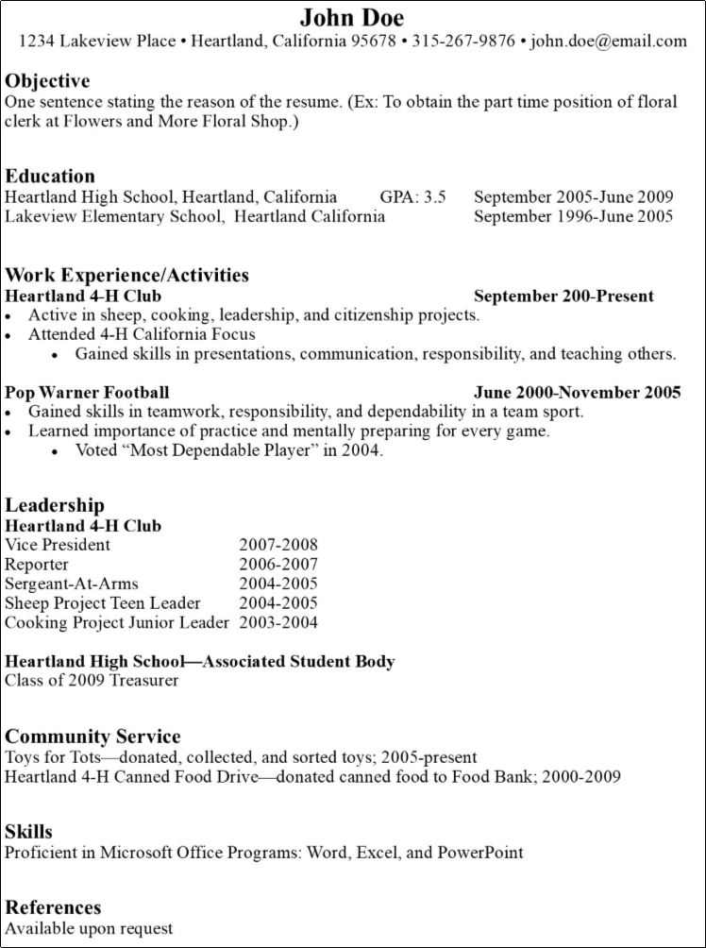
Tips:
One inch margins on all edges.
Appropriate font and size.
Suggested fonts: Times New Roman, Garamond, Arial
Sizes: Name: 14 or 16, Headings: 12 bold or 14, Text: 12 or 10
Your name should be the largest type on the page.
Include experience and activity dates and order beginning with the most recent.
Experiences, Activities, Leadership, and Community Service are all a very important part of you. List skills learned in activities or work experience. Every leadership role or participation is important.
While in school, education comes first. After your first full time position, experience comes over education.
Unless asked for, references can be left off or labeled as “Available upon request.”

Virginia 4-H Shooting Education Ambassador
Reference Form
Applicant’s Name: ________________________________________________________
Reference Name: ____________________________ Phone: ______________________
Address: ________________________________________________________________ How long have you known this applicant? _____________________________________ In what capacity have you known this applicant?
_____________________________________________________________________________________________________________________________________________________________________________________________________________________
_______________________________________________________________________
Please rate the applicant in the following areas
Area | Above Average | Average | Below average
Emotional maturity and judgment
Leadership abilities
Flexibility
Communication skills
Enthusiasm and energy
Self-confidence
Responsibility
Respect for authority
Respect for policies and procedures
Trustworthiness
Willingness to work with others
Please offer any additional comments, which might prove to be helpful in the section process of the applicant (attachments are acceptable).
______________________________________________________________________________________________________________________________________________
_______________________________________________________________________
Completed references are confidential and MUST be returned to the applicant in a signed, sealed envelope prior to Monday, August 28, 2023
Questions? Contact Robert Tillotson at ricochetrobert56@gmail.com or 434-841-6055
Virginia 4-H Shooting Education Ambassador
Reference Form
Applicant’s Name: ________________________________________________________
Reference Name: ____________________________ Phone: ______________________
Address: ________________________________________________________________ How long have you known this applicant? _____________________________________ In what capacity have you known this applicant?
_____________________________________________________________________________________________________________________________________________________________________________________________________________________
_______________________________________________________________________
Please rate the applicant in the following areas
Area | Above Average | Average | Below average
Emotional maturity and judgment
Leadership abilities
Flexibility
Communication skills
Enthusiasm and energy
Self-confidence
Responsibility
Respect for authority
Respect for policies and procedures
Trustworthiness
Willingness to work with others
Please offer any additional comments, which might prove to be helpful in the section process of the applicant (attachments are acceptable).
______________________________________________________________________________________________________________________________________________
_______________________________________________________________________
Completed references are confidential and MUST be returned to the applicant in a signed, sealed envelope prior to Monday, August 28, 2023
Questions? Contact Robert Tillotson at ricochetrobert56@gmail.com or 434-841-6055
Virginia 4-H Shooting Education Ambassador
Reference Form
Applicant’s Name: ________________________________________________________
Reference Name: ____________________________ Phone: ______________________
Address: ________________________________________________________________ How long have you known this applicant? _____________________________________ In what capacity have you known this applicant?
_____________________________________________________________________________________________________________________________________________________________________________________________________________________
_______________________________________________________________________
Please rate the applicant in the following areas
Area | Above Average | Average | Below average
Emotional maturity and judgment
Leadership abilities
Flexibility
Communication skills
Enthusiasm and energy
Self-confidence
Responsibility
Respect for authority
Respect for policies and procedures
Trustworthiness
Willingness to work with others
Please offer any additional comments, which might prove to be helpful in the section process of the applicant (attachments are acceptable).
______________________________________________________________________________________________________________________________________________
_______________________________________________________________________
Completed references are confidential and MUST be returned to the applicant in a signed, sealed envelope prior to Monday, August 28, 2023
Questions? Contact Robert Tillotson at ricochetrobert56@gmail.com or 434-841-6055

