April 28, 2025

TO: Retiree Participants of PWC Health Insurance

FROM: PWC Human Resources Benefits Team

RE: Health, Dental, VSP Insurance Open Enrollment – New Coverage Effective July 1, 2025

The County Government’s Health Insurance Open Enrollment period is through May 31, 2025. Because you are currently enrolled in County sponsored medical, dental and/or VSP insurance as a retiree, you have an annual opportunity to elect a different plan; however, you may not add a plan or dependents. If you are not making changes to your present coverage, no action is necessary.

If you would like to make changes, all enrollment forms, rates, and change information are available on the retiree website at www.pwcgov.org/retirees, or email us at HRBenefitsTeam@pwcgov.org.

Plan highlights:
- Anthem:
  - Members in the POS plan can use out-of-area PPO doctors, with proper referrals as necessary, and only pay in-network costs;
  - LiveHealth Online care for PCP and mental health services are covered at 100% with no copay.
- Kaiser Permanente:
  - Telehealth visits have no copay;
  - Travel Line assists you with care before or while you travel. Call 951-268-3900
- Delta Dental:
  - Healthy Smile, Healthy You: allows members with certain health conditions, like diabetes, high-risk cardiac conditions, weakened immune systems, or cancer treatments to receive an additional cleaning and exam beyond the plan limit, per benefit period. Contact Delta Dental for more information.
  - Prevention First program allows members to have their entire annual benefit maximum ($2,000 Enhanced Plan and $1,000 Core Plan) available towards Basic or Major Services (Preventive services are excluded from the annual benefit maximum).
  - Amplifon offers special savings on hearing aids to our members. Delta Dental members can save an average of 66% off retail pricing on hearing aids through this partnership. Call Amplifon at 877-593-0051 for more information.
- VSP: Remember to tell your eye doctor you have VSP if you are enrolled in this plan. VSP does not send ID cards to members. Create an online account to view benefits and download an ID card at www.vsp.com.

You are invited to attend the in-person Benefits Fairs, where benefits representatives from our insurance and retirement plans will be available to explain benefits and answer questions.

Location | Date and Time | Address
Sudley North, Jean McCoy conference room | May 22nd, 8:30 am to 11:30 am | 7987 Ashton Ave, Manassas, VA 20109
McCoart, Atrium | May 22nd , 1 pm to 4 pm | 1 County Complex Ct, Woodbridge, VA 22192

OVER

The new rates are listed below, and your current elections are highlighted.

If you are not making changes to your present coverage, no action is necessary. Your monthly premium deductions will be automatically adjusted to reflect new monthly premiums. You may email Benefits staff at HRBenefitsTeam@pwcgov.org or call 703-792-6640 to be routed to a Benefits Analyst if you have questions.

July 1, 2025 – June 30, 2026 MONTHLY INSURANCE PREMIUMS

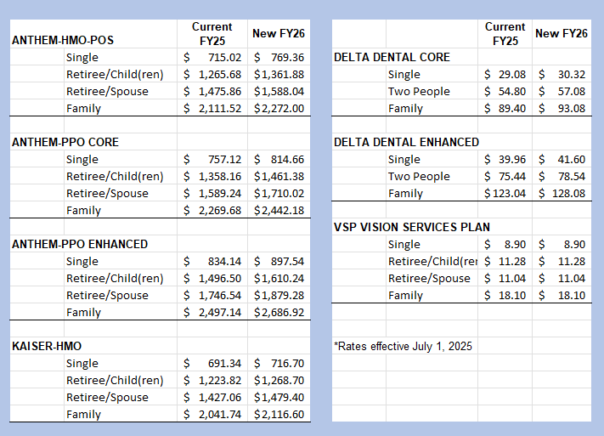

Questions about your Bolton credit? You may email Bolton at PWCCredit@boltonusa.com, or contact them 8 am to 5 pm, M-F, at 866-340-9789

Don’t forget to check the retiree website!!

www.pwcgov.org/retirees
Did You Know? If you download the mobile apps for Anthem (Sydney), Delta Dental of VA, Kaiser and VSP, you can access your account and your ID card right in the app?

