Contact: Deborah K. Campbell
703-792-5328
dcampbell@pwcgov.org

M e d i a R e l e a s e
For Immediate Release

Flattened Cardboard Saves Space and Money
Prince William County Cardboard Recycling Tips

Prince William, VA, January 19, 2026 - Cardboard boxes take up a lot of space. Flattening boxes before placing them in the curbside bin, drop-off trailers in the community, or other recycling containers save space and allows more recyclable material to fit in the receptacle. This makes the recycling collection process more efficient in the County. It also prevents boxes from getting stuck in the sorting equipment.

Flattening cardboard helps to maximize the available space in recycling containers. Maximizing the amount of cardboard packaging and other materials for recycling helps preserve natural resources and contributes to building a more circular economy.

Another important recycling tip, cardboard should be free of any packing materials such as plastic, Styrofoam, or bubble wrap. Although many of these packing items may be recycled, these materials do not belong with the regular recycling collection in Prince William County.

With the increase of online shopping, weekly meal deliveries and other conveniences, cardboard and paperboard are mainstay in the waste and recycling stream. Prince William County residents are encouraged to make an extra effort to recycle packaging properly.
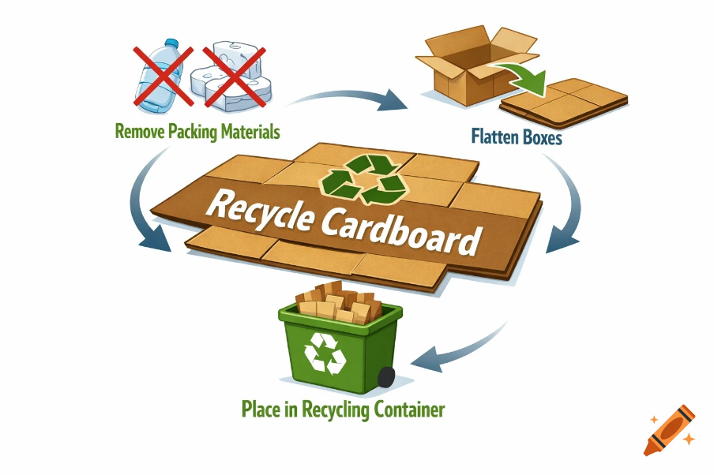
Cardboard Recycling Tips:
- Remove Packing Materials: all plastic, flex films, Styrofoam and packing peanuts. These items should not be placed in your recycling cart.

- Flatten Boxes: flatten all cardboard boxes, tape and labels are okay.

- Place flattened cardboard in recycling container! Please use the appropriate recycling bin.

- Residents may also bring their empty cardboard boxes to the Landfill or Compost Facility and place them in the compactor to be flattened.

Use the Prince Wiliam County Solid Waste Division A-Z Disposal Guide at pwcacva.gov/disposalguide and get information on recycling and appropriate disposal of more than 300 items in Prince William County.

