Tips for Reducing Yard Waste

Yard waste can really be a challenge this time of year and the Solid Waste Division would like to remind residents that reusing your yard waste can really help reduce waste and make your lawn and garden healthier and more beautiful in the process. While “grasscycling” and composting may not come to mind when you think about waste reduction and recycling, but they are both great examples of these concepts. Yard waste is one of the largest categories of waste. It makes up more than 13% of the total trash generated nationally as well as in Prince William County. Since the COVID-19 health crisis began, the Prince William County Landfill and Balls Ford Road Compost Facility have seen a surge of activity over the last months and the Solid Waste Division has had to suspend or restrict some programs and has placed limits on the delivery of yard waste to our facilities.

Grasscycling
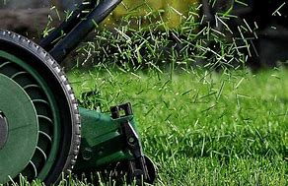
Grasscycling is a simple and natural approach to maintaining your lawn. Simply leave the grass clippings are left on the lawn after mowing. The grass clippings will decompose quickly, releasing valuable nutrients back into the soil. Grasscycling has many benefits: it saves time, money and the resources needed to pick up and handle the clippings for landfilling. When practiced in conjunction with proper lawn management, grasscycling can reduce water and fertilizer requirements, mowing time, and disposal costs.

Grass clippings are 75% to 85% water. When mowed regularly, the grass quickly decomposes and releases nutrients to fertilize the lawn. The nitrogen contained in grass clippings almost equals the recommended application rate of nitrogen for healthy turf (5 pounds of nitrogen per 1000 square feet per year). While some of this nitrogen is lost through the decomposition process, grasscycling can have the overall impact of reducing fertilization requirements by 25% or more. Grasscycling saves money, plus it benefits the environment by reducing waste.

Just remove the bag and almost any lawnmower can grasscycle. Caution, if your mower does not have a safety flap that covers the opening where the bag fits into the chute, or a plug for the chute, contact a local retailer to purchase a retrofit kit. Do not compromise the mower's safety systems.

Composting
Another good recycling technique for your lawn and garden is composting. Composting is a natural process, which speeds up the natural decomposition of organic matter (e.g., grass, leaves, garden debris, food waste, etc.). Composting “recycles” organic matter into a valuable soil amendment called compost.

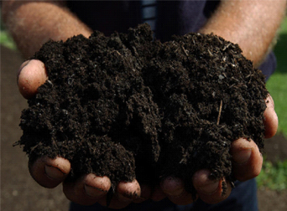
Instead of bagging up leaves, grass clippings and other garden waste—try composting them instead. Raked leaves, mowed grass and trimmed bushes and branches can all be used to make valuable landscape loving compost. You do not need any special equipment to compost, but a compost bin will help keep your compost area tidy. Compost bins are available at local hardware stores and on-line.

Finished compost can be used to improve the soil structure which helps keep the soil together and reduces erosion. Compost can be used in vegetable gardens and flower beds, lawns, and even mixed with potting soil.

The annual spring Prince William Compost Awareness Day event has been postponed, but there are lots of good resources available from home. To learn more about yard waste composting, grasscycling, mowing height, watering, lawn management, etc., visit internet sites like Virginia Cooperative Extension, www.ext.vt.edu; Prince William Library pwcgov.org/digitallibrary or other information resources or email Extension Horticulture Help Desk weekdays at master_gardener@pwcgov.org. To learn more about guidelines for disposal at the Prince William County Landfill and the Balls Ford Compost facility, please visit www.pwcgov.org/trashandrecycling.

